For the attention of:

The Prime Minister
The Rt Hon. David Cameron MP

UK Climate Engineering Dossier
Version 2 (Draft 8)
?.?.2014

This document must only be distributed in full
? pages
Look-Up.org.uk
Author: Ian Simpson

UK Climate Engineering Dossier
Presenting evidence and theory of current, active climate engineering programs in UK and European airspace, with specific reference to atmospheric aerosol spraying being conducted by commercial freight and passenger aircraft.

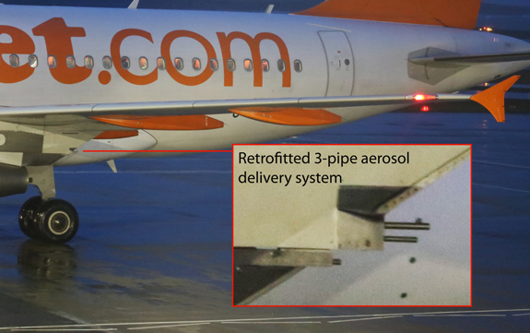
Section 3 – Contents

- Addressee
- Title page
- Contents (this section)
- About this document
- About the author
- Lists of intended recipients

- Introduction
- Visual evidence and the 3 main programs identified to date
- High Bypass Turbofan Engines
- The distribution infrastructure of the substances used in the programs
- The containers used to transport the substances
- The retro-fitted dispersal equipment on commercial aircraft
- Night flights and The First Wave
- Routing, population density and the link to health
- Aerotoxic syndrome
- Military operations and possible links commercial aviation programs
- The science and the links to political ideology
- National and International Subterfuge
- Crime Against Humanity?
- Conclusions
- Summary
- List of demands
- The current epetition lodged by the author

Section 4 - About this document

This document will be distributed in printed format, but is also available for inspection and download on the internet via my website – www.look-up.org.uk
Online versions are in Adobe .pdf format and hence printable. Adobe reader will be required to open and print the document.
It should be noted that only basic information in each section can be included so as to keep the document reasonably succinct, but the website contains more detailed evidence relating to each section of this document. If a section is not directly referenced on the website at this time, it will be soon, as and when I have the time to update it.
Version 1 of the document was delivered to No. 10 Downing Street on 27th September 2014. Some sections may be incomplete as some investigations are still underway, and information is being received on a daily basis, but it does contain sufficient evidence, I feel, to be submitted as a formal demand to our Prime Minister and Deputy Prime Minister to investigate and take urgent action in the matters detailed within it. The evidence presented herein is still being refined and under constant review, and hence being updated regularly. Further updates will also be handed into Downing Street in printed format, as and when published, so as to ensure updated information is seen by the Prime Minister and Deputy Prime Minister.
This document will be circulated widely as detailed in Section 6- Lists of intended recipients. The list of intended recipients itself may also be updated at any time in line with new versions.
Each printed document will be labelled with a version number and a date. Each time a revision is made a new version of the online document will be published, with all previous versions remaining available.
The URL for download of the online version is:
http://www.look-up.org.uk/dossier
Look-Up.org.uk authorises any person to print and distribute the latest versions. No copyright or distribution restrictions apply. Look-Up.org.uk is owned and run by Ian Simpson, the author of this document, and I have produced this document in the public interest, and hence waive any distribution or publication restrictions of any kind, here in the UK or internationally.
No reward is due in the event of its use by any person or organisation for whatsoever purpose, as long as the intended purpose is to propagate the information in a constructive or positive way to further awareness about this issue. Critical analysis is encouraged, but blatant ridicule will be considered a breach of this agreement, especially when it is designed specifically to undermine, and especially when it is unfounded, based on falsified information, or simply unverified information. Once again it is re-iterated that the document shall not be used in part, and can only be reproduced in full.
Sensible, constructive discussion and evaluation of the document is fully encouraged, especially in the media and scientific communities. The author cannot claim to be 100% correct about all the claims herein, and cannot claim to know everything about the issue as a whole, but is confident that the information contained herein is a reasonably accurate representation of what is happening, and hence conveys important information to the readers, which will hopefully be investigated further by others. That is the primary purpose of the document and aim of the author.

Section 5 – About the author

I am a 40 something university technician. Educated to 1st year of A levels in Biology, Chemistry and Italian. After the first year of A levels I decided to leave 6th form college to do a business studies diploma.
Having left higher education I soon found work in west end theatres and decided that was where I preferred to be, and so I set about carving a career in sound and lighting, eventually specialising in sound, then sound recording and eventually starting my own business.
I am what might be described as a science ‘buff’. I have been reading New Scientist regularly since the age of 15, even dipping in and out of the odd journal on the rare occasion when I needed to know more about a particular issue. It could be said therefore that I have a good basic understanding of most scientific principles, and a good general knowledge of the world of science at large.
Due to having no official scientific training, this document does not follow any scientific or academic format. I hope that will not detract from its importance and impact, and that readers will focus on the information contained in it. I have attempted to present it more as a legal document than a scientific report.
Despite not being qualified in any of the areas of science or engineering that this topic deals with, and despite the fact that much of what is contained herein is based on conjecture, I feel there is sufficient important information to warrant writing and distributing this document, for further consideration by others if nothing else, and to present this information to our ministers so they can no longer claim not to have seen any evidence to suggest the presence of active climate engineering, as they have done so to date.
Ian Simpson

Section 6 – Lists of intended recipients

2 printed copies of Version 1 were hand-delivered to No. 10 Downing Street on 27th September 2014, for the attention of The Prime Minister The Rt Hon. David Cameron MP and The Deputy Prime Minister The Rt Hon. Nick Clegg MP
Further copies will be delivered both electronically and by hand, in printed format, to the remaining ministers detailed below.

Government Ministers
Secretary of State for Defence The Rt Hon. Michael Fallon MP
Secretary of State for Business, Innovation and Skills The Rt Hon. Vince Cable MP
Secretary of State for Health The Rt Hon. Jeremy Hunt MP
Secretary of State for Energy and Climate Change The Rt Hon. Ed Davey MP
Secretary of State for Transport The Rt Hon. Patrick McLoughlin MP
Secretary of State for Environment, Food and Rural Affairs The Rt Hon. Elizabeth Truss MP

Aviation, weather and security agencies
(Full details of the recipients will be included in the next version, but are in note form here)
The CAA
BAA
NATS
EASA
Airbus - UK
Airbus – France
Boeing tbc
Royal Aeronautical Society
The MET Office
MI5
The Metropolitan Police – Heathrow
Scotland Yard

National Crime Agency

UK registered airlines
AirTanker
Atlantic Airlines
BA CityFlyer
BMI Regional
British Airways
Cello Aviation
DHL Air UK
Eastern Airways
EasyJet
Flybe
Jet2
Loganair
Monarch Airlines
Thomas Cook Airlines
Thomson Airways
Titan Airways
Virgin Atlantic Airways

Media organisations
The Guardian Newspaper - London
The Times Newspaper - London
The Daily Mail Newspaper - London
The Telegraph Newspaper – London

Legal firms and organisations
I will also be copying the document to other selected legal organisations and solicitors for their inspection. A final list of these has not yet been decided, but will be published in a later version of this document to be made available on the website.

Other
I may choose at any stage to further distribute this document to any organisations or persons as I see fit at any future date so as to promote awareness or further the campaign for whatever reason. I will release details of any organisation or persons on the website unless I deem it helpful not to do so for whatsoever reason.

Publication online
The document is, and will remain, available for public viewing and download by anyone on at the following URL:

Look-Up.org.uk/dossier

Section 7 – Introduction

In April 2013 I first noticed unusual aircraft activity in our skies near London. Groups of 3 aircraft travelling in very close formation at low altitude, around 22,000ft, leaving dense persisting trails. The trails from these aircraft did not disperse as one would expect, but lingered, expanding slowly to form what can only be described as a thin cloud-like layer across the entire sky. The sky went from clear blue at dawn to completely grey by late morning, and purely as a result of trails left by repeated passes from several groups of these aircraft.
Since that day I have investigated this phenomenon in great detail. The evidence I have collated here gives a comprehensive picture of what can only be described as widespread, active climate engineering activities across UK airspace. Whether what we see is still in the trial stage or is a fully formed climate engineering program is still unclear. Anecdotal evidence suggests this type of activity has been witnessed for many years now, so this would suggest the latter. Reports from other countries suggest this is also occurring in European airspace, and other parts of world.
These programs are being conducted in UK airspace mostly by commercial airlines, both UK and internationally based. The aircraft seen to be leaving low-altitude trails are mostly Airbus A320 family and Boeing 737 and 777 models, though other models may also be involved as detailed in the body of this document. All aircraft that are seen leaving low-altitude trails have been modified with pipes in the pylon. Those pipes are not standard to the design of the aircraft. I know this to be the case, at least for Airbus, as Airbus recently confirmed to me that their aircraft do not leave the factory with pylon pipes.
Every day now our sky and the air we breathe is affected to some degree, and even completely defined on many days, by substances sprayed from aircraft. Several different types of programs and substances have been identified to date as will be described in the body of this document. It is unclear yet exactly what is being sprayed but sampling and testing is being planned so as to try and identify the substances being used, and their potential harmful effects if any.
This situation is completely unacceptable. No public consultation has been conducted, and no public approval has been gained or even sought. Public debates on the issue have been sparse and have focused on, and tried to imply, that these programs are only being ‘considered’ and are not yet being implemented. I have attended many lectures by eminent institutions such as the Royal Society, Oxford Martin College and UCL amongst others, and there is no admission by any parties that this is already happening, despite overwhelming visual evidence of its presence, and a mountain of anecdotal and photographic evidence in online forums. Organisations that seem to be knowledgeable about and connected with these programs, such as selected university departments, the CAA, MET Office and possibly NATS (the latter being just an assumption at this stage), could be described as being involved in a program of subterfuge. There is no doubt in my mind now, having considered all aspects of this situation in great detail and over time, that these organisations are aware of these programs, at senior management level at least, and are actively attempting to hide their presence. I will expand on this in a new section: Section 17 - National and International Subterfuge.
The situation as a whole is extremely disturbing. That national institutions can be involved in covering up such a vast and obvious operations is unfathomable to some, but to the inquisitive mind it takes only a short while to look at the evidence and realise that the story we are being presented with is inconsistent at best, and completely fictitious at worst.
This document attempts to do two primary things:
- To present that evidence in a basic format so as to allow the reader to understand the situation as a whole and recognise the inconsistencies.
- Hold accountable, by its very existence, those who are either perpetrating these programs, or attempting to hide their existence in any way, be it actively or passively, by simply not admitting to their existence.
Evidence never disappears. Even if all the points raised here are addressed and the program altered to mask them, it can never be completely hidden and others will be able to understand what to look for and continue exposing it.

Section 9 - Visual Evidence and the 3 programs identified to date

This section is divided into subsections. We can glean a lot just from observation of the aircraft and their behaviour. The subsections are as follows.
9.1 – The general appearance of the sky and the 3 types of programs
9.2 – Altitude
9.3 – OWOW. One with, one without
9.4 - Different types of trails from different aircraft in the same area of sky
9.5 - Different types of trails from different engines on the same aircraft
9.6 - No time for the condensation to condense
9.7 - New types of cloud formations

9.1 – The general appearance of our skies
One of the first clues to most people that something is wrong or that something strange is going on in our skies is the unusual appearance of cloud formations. We now see many new cloud formations, and those cloud formations behaving very strangely and having unusual appearances.
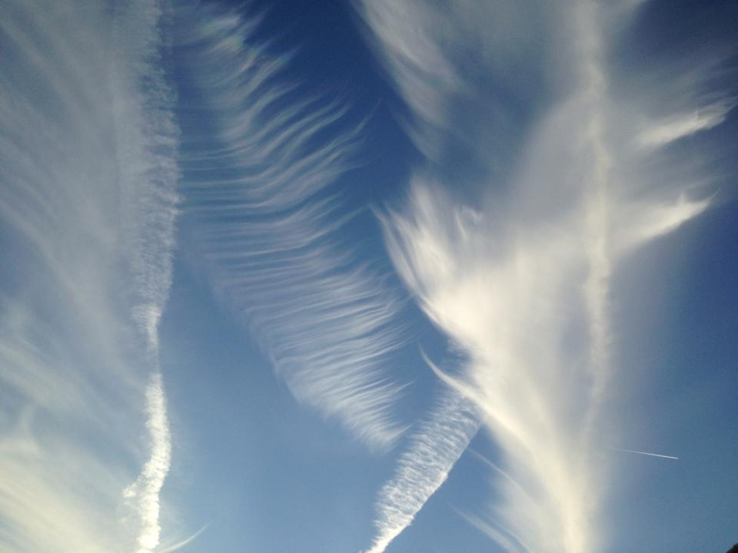

This is NOT a normal sky. Despite the increasing use of normalising images in advertising and on television, most people are still able to recognise that our skies should not look like this, and have never done so in the past.
We now see a host of strange wispy, streaky, bobbly and generally messy skies all around us on most days when the sky is actually visible.
Below we analyse some of the different types of formations that occur as a result of substances sprayed deliberately from aircraft over the UK.

We deal first with the 3-part persistent trails.
Delivered mostly from Airbus A320 Family aircraft. We think A380 may also have been fitted with similar systems, but have no photographic evidence to date and have not managed to photograph or film any in action as yet and so cannot implicate them at this stage. NB. Other types of aircraft also leave persistent trails, but they are not the distinctive 3 part ones, as with the A320 aircraft.
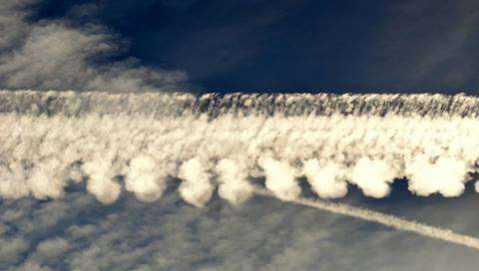
Above is an image of a trail left by an Airbus A320 Family aircraft. There is a clear 3-part structure to this trail, as also seen on further images. I believe this is as a direct result of the 3-pipe aerosol delivery systems fitted to them.
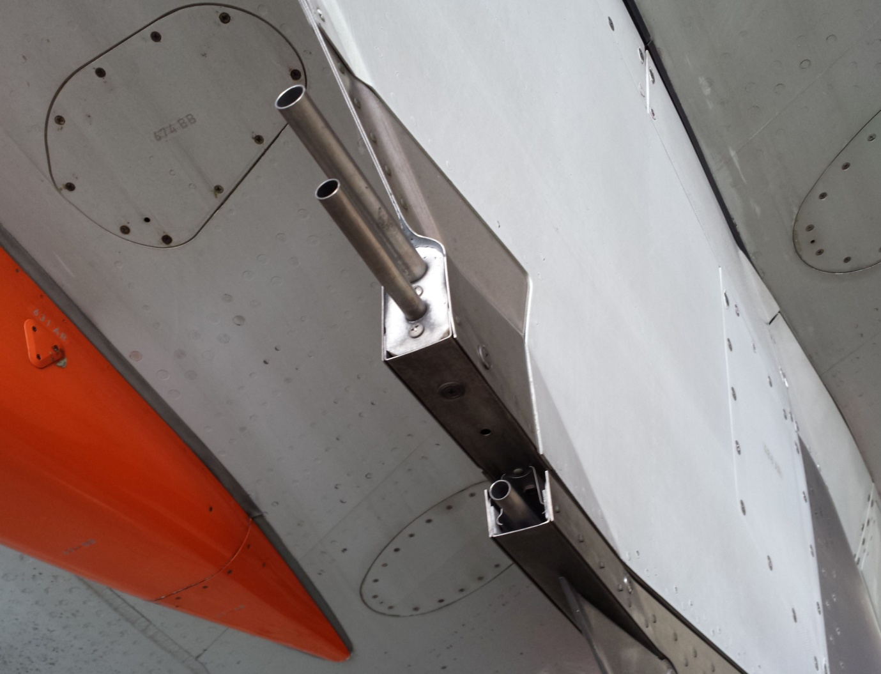
I expand on the technology in Section 11 - The pipes which have been retro-fitted to aircraft
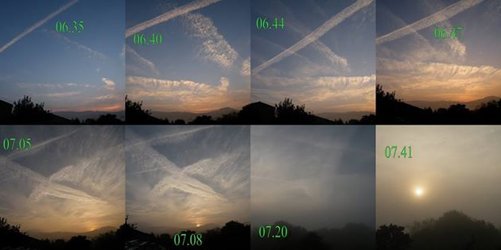
The above image is an excellent example of the effect that these persistent trails can have on the sky across an entire area. This was taken near the North Wales / Shropshire border in 2014, and shows the deterioration from blue sky at dawn to a completely grey sky just one hour later, entirely as a result of trails left by aircraft. We know this to be the result of persistent trails left by modified aircraft as described above, but even if this were simple condensation as some try to claim, it would be a serious enough issue to warrant Investigation and action to re-route aircraft.
More examples of this type can be seen on the website, along with time-lapse films taken in the UK showing this process evolving.

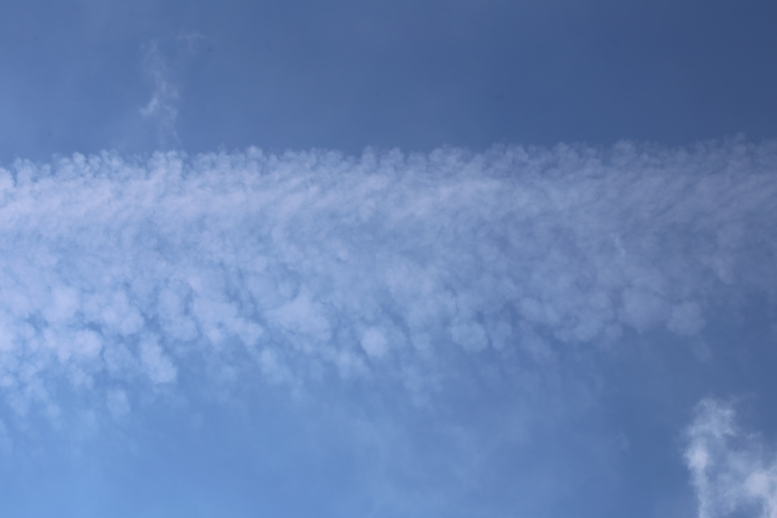
The image above is of a 3-part persistent trail left by an Airbus A320. This is at about 15 minutes from delivery by the aircraft. We see the familiar pattern emerging. The upper part of the trail is composed of a mixture of the substances emitted from the upper 2 pipes of the dispersal system, and the lower patchy formations are the beginning of the cloud types that go on to increase in volume and form a thin layer of cloud as we see in the image below. In high humidity this will expand and become denser, resulting in the type of cloud-like formations the MET Office has recently named Mammatus.
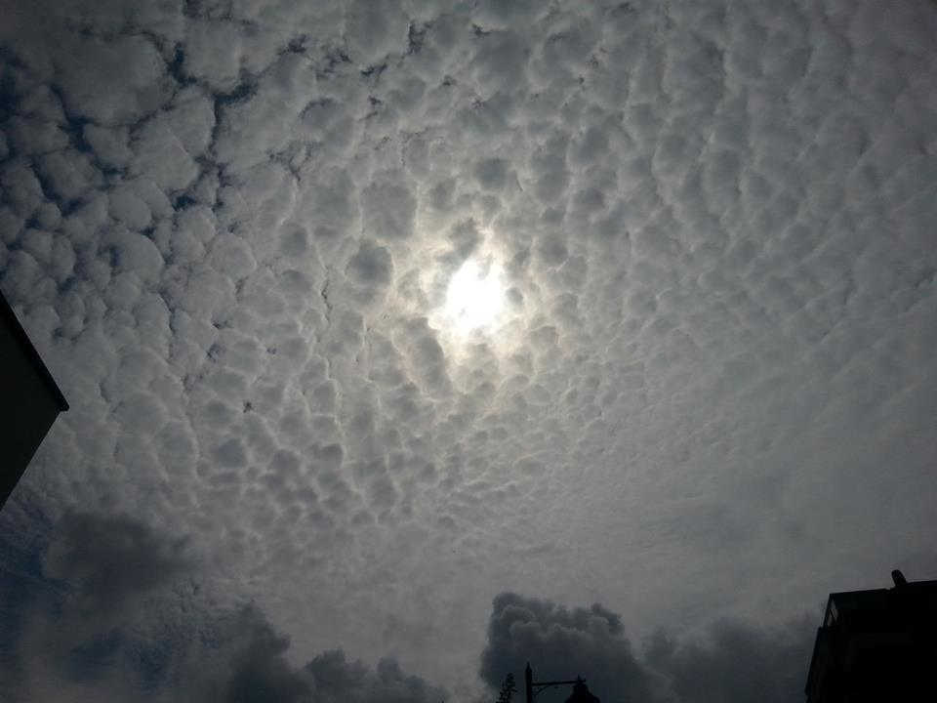
The behaviour of the cloud-like formations produced from these aircraft can vary considerably. It seems to be the case that what we are witnessing is large scale trials, or actual programs, of weather modification or climate engineering. The folllowing series of images are all chemically induced cloud-like formations created from substances ejected from aircraft.
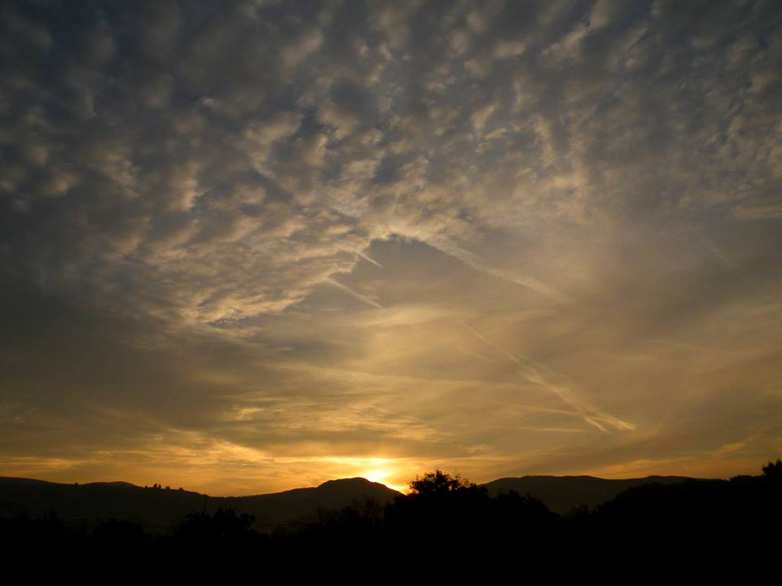

The above image shows a sky dominated by a mess of formations from persistent trails. The upper section shows forming Mammatus cloud, and the lower section shows a host of expanding trails which form what could be refered to as a smog layer.
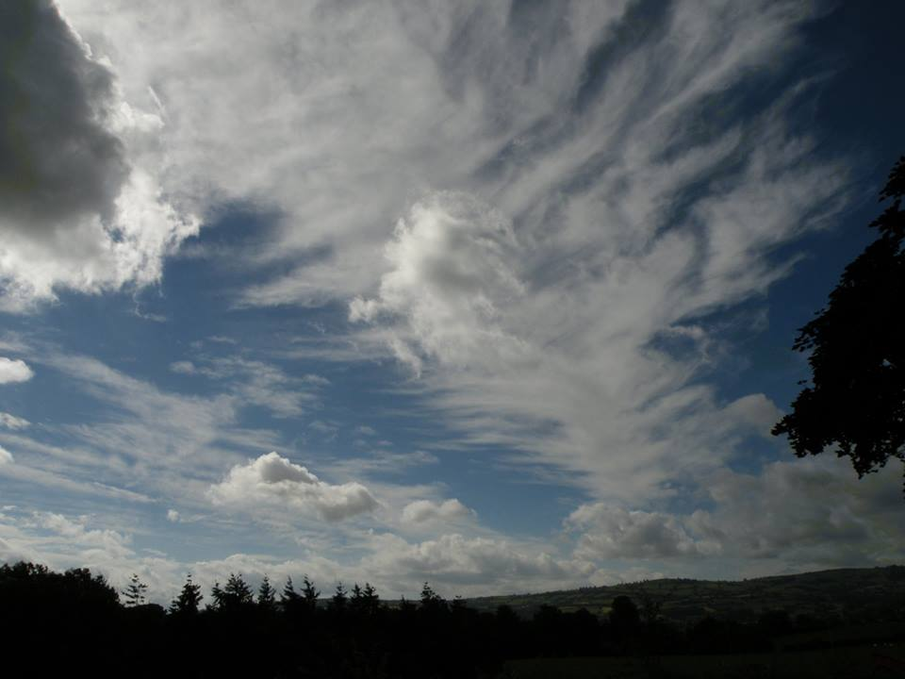
The image above shows another sky full of both types of aircraft-made cloud-like formations. We focus here on the long wispy structure that travels from lower right to upper left. This is, once again, created by the persistent trails ejected by the Airbus 3-pipe delivery systems.
It is not clear if this pattern is the result of different substances being used, some other variation in what is being sprayed, or the result of different atmospheric conditions. We need more extensive observations to be able to know this with any degree of confidence.
This type of formation often spreads and seperates into arrowor feather-like shapes (see next page). They seemed to appear in early 2014 and were named Uncinus Cloud by the MET Office, in an attempt to convince the public that this is normal cloud, and that it has always existed. They are also associated with rainfall. Even the MET Offcie’s own description suggests that they are seen prior to rain, which is a very big clue. History tells us that big dark cumulous is the bringer of rain, so the fact that this new type of cloud is being described as the precursor to rain is an important clue as to exactly what is going on here.
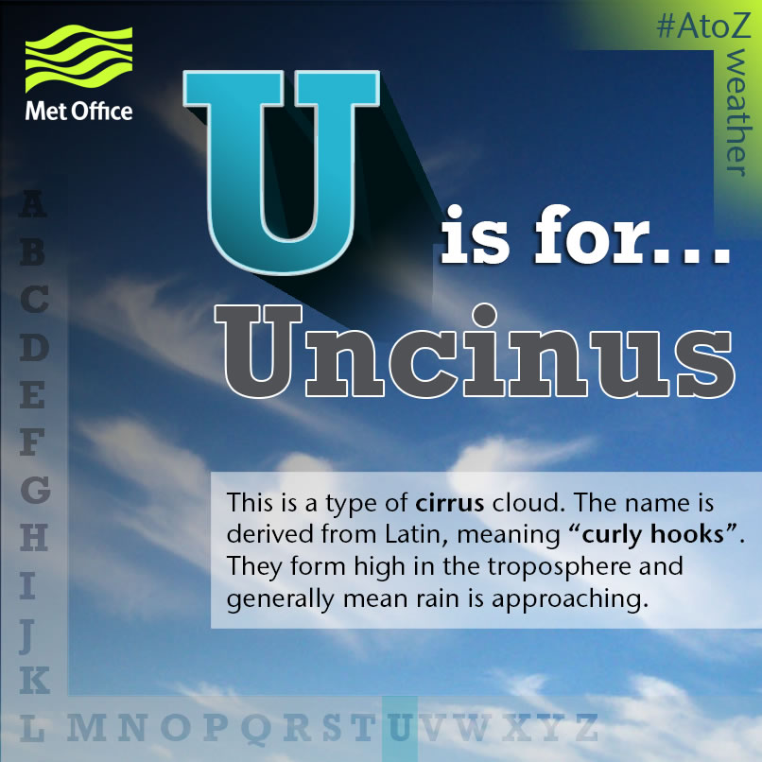

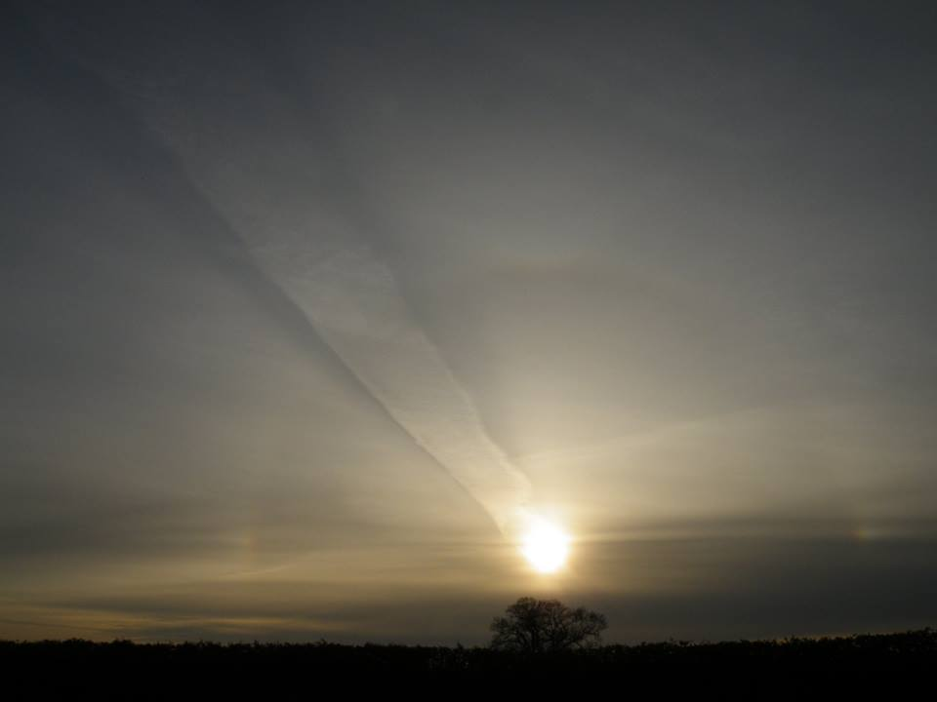
Above is an image showing what many describe as a white-out or blanket. The single characteristic of chemically induced cloud-like formations is that they always form thin layers. (NB induced cumulus can form from other processes described in the next section). The sun is usually visible through the layer. Again it is unclear if this effect is simply as a result of variations in the chemicals used and therefore intended, or if unfavourable conditions have resulted in cloud-like formations not being produced and hence an unintended effect. Here we also see a trail expanding slowly to merge with the layer. We also see another new phenomenon called a ‘sun dog’, or ‘halo’, forming. This is when the sunlight is diffracted as it penetrates the layer, forming a round halo with rainbow like edges.
Once again the MET Office have attempted to convince the public that this is a natural phenomenon. They describe it as a ‘halo’, which has existed as a word previously, but this is certainly not a natural phenomenon that we see here.
This image alone is strong evidence of what aircraft trails can do to a sky. The blocking of sunlight constitutes a serious health risk to humans, and even leaving aside the direct health impacts, is a completely unacceptable consequence of air traffic, even if it were innocuous.
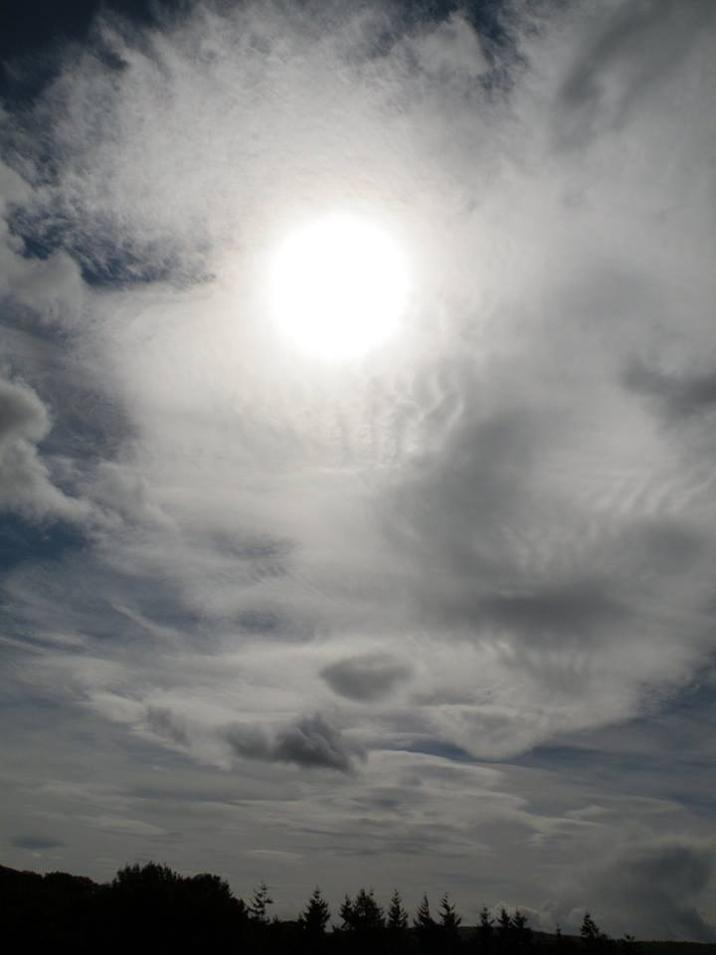
Above is another example of the chemically induced cloud-like formations that occur on days of heavy spraying form aircraft. Once again we see the layers are thin and the sun is visible though the mess of strange formations.
The following 2 images both clearly show the linear structure of the cloud-like formations. Clouds have never been able to form naturally into linear shapes. The chance of this happening naturally on a regular basis purely by chance are zero, so we can conclude that all the formations we see here are as a result of expanding trails from aircraft. Again we can rely on the point that even if this were simply condensation (which it clearly isn’t), it would still be an unacceptable situation, to have entire skies dominated by these formations produced by air traffic.

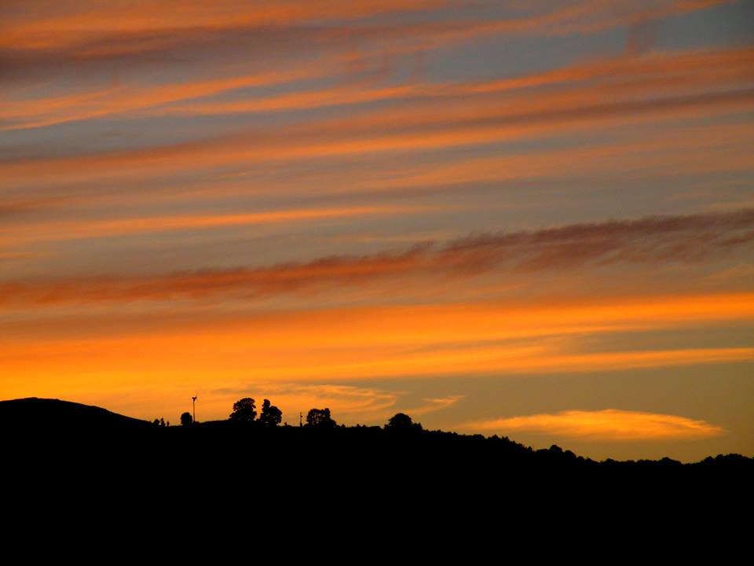

The next image shows more examples of ‘freshly laid’ trails from aircraft at various stages of expansion. The familiar droplet or bracelet pattern of the 3-part trails can be clearly seen on one of the trails. If one looks at the sky on days such as this where the sky is relatively clear, it becomes obvious quite quickly that aircraft are producing huge amounts of cloud-like formations that can often dominate our skies, block our sunshine and completely define our weather on what would otherwise have been lovely clear, sunny days.

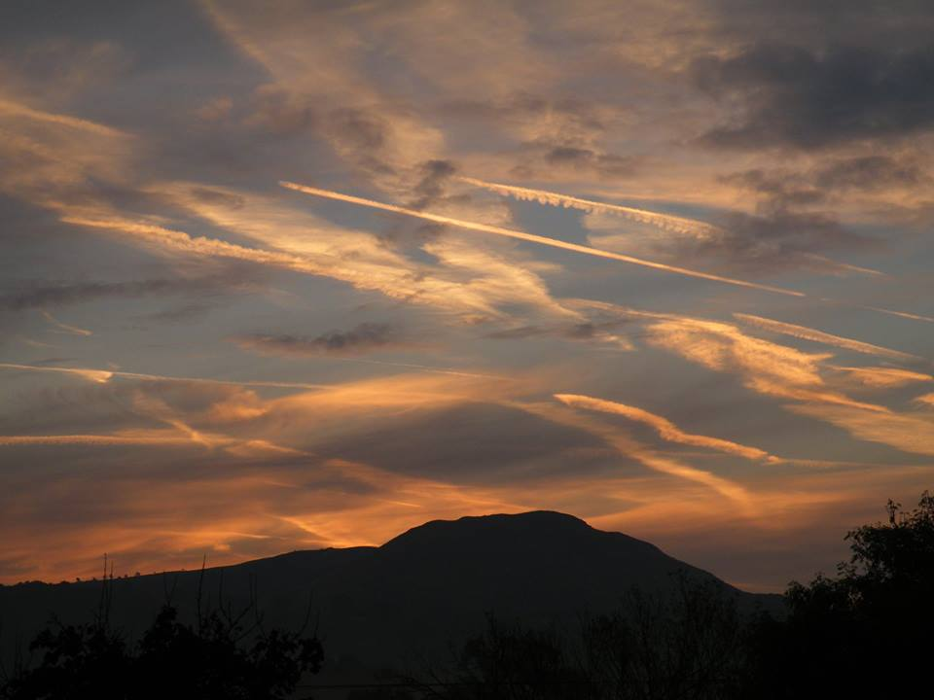

Punch Holes
The two images below are examples of what can happen in particular conditions. One way of identifying unnatural cloud derived from aircraft, specifically those produced by the 3-pipe dispersal systems, is by the fact that it is always seen in thin layers. Quite why that is the case is unclear. It seems to sit in a thin layer at whatever altitude it may have been sprayed at. Normally we see this type of activity occurring at around 25,000ft, but this can vary considerably with aircraft being seen to exhibit this behaviour as low as 18,000ft and at more normal cruising altitudes of 24,000 to 30,000ft. Not enough detailed observation has been carried out to date to establish if any variance in the cloud-like structures produced is as a result of altitude, and once the layer has formed it is very difficult to estimate the altitude without an aircraft being present. The two images we see here are of ‘punch holes’. The MET Office claims that these are caused by ice crystals falling. A more likely explanation is that the structure of the cloud-like layer is simply collapsing due to the lack of sufficient humidity.

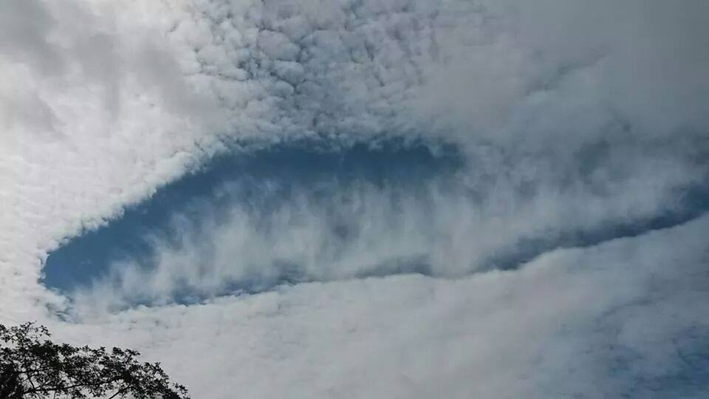

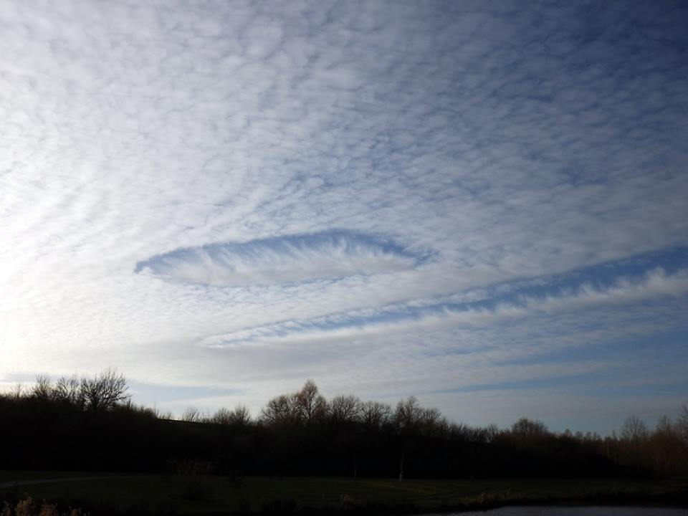
Haze
Our air is now full of a near constant haze of nano-scale polymer fibres.
It is not possible at this stage to conclusively prove the link from aircraft to haze, and then to what we see in our throats, but it is also hard to think of any other explanation. We see aircraft fly over at low altitude leaving shimmering trails that disperse quickly, we see the sky fill up with haze, we find our eyes and throats itching regularly, and we find structures that seem to resemble ‘blobs’ of hair-like filaments in our mouths and throats.
These fibres can also be observed in house dust. The larger ones are just about visible to the naked eye, and are probably settled due to their larger size, but the majority of these fibres are so small that they are invisible under normal conditions and float around in the air we breathe. If one observes the air at night under a strong light and you see the air we breathe is a soup of fibres. This is not dust or moisture, and is present all day every day, irrespective of your location or the atmospheric conditions.
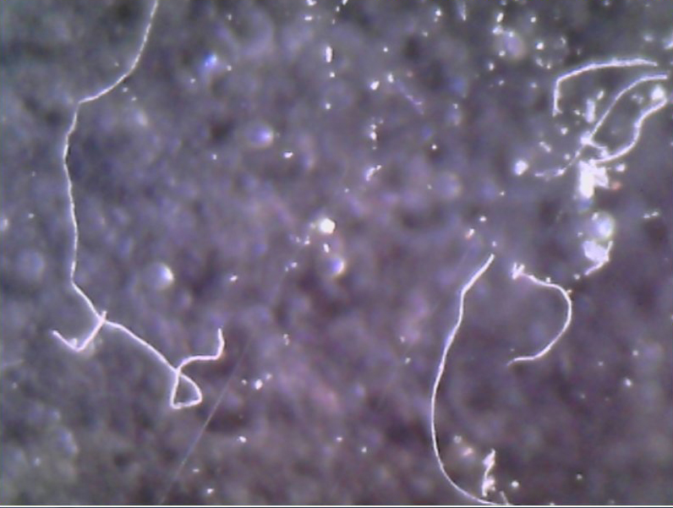
Image above: fibres @ x400
Furthermore we breathe these fibres in every day. We can see the result of these fibres coagulating in our throats if we gargle with red wine. They seem to collect on our tongues and in the throat, and form structures that stick to our skin in our throats. This is perhaps the most disturbing aspect of the topic as a whole.
It is unclear what purpose these fibres have in the body, if any, but they do seem to be reacting in some way with other enviro-toxins such as compounds found in perfumes and other fragranced products. I will be writing a more detailed report on the website specifically about the fibres, detailing initial theories about their role and effect on the human body.
I also refer again to the potential health implications of these fibres in Section 14 – Crime Against Humanity?
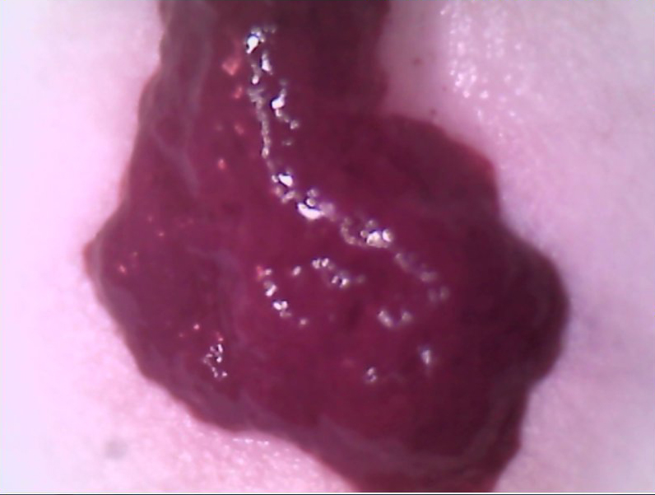
A freshly expectorated sample of coagulated or formed fibres. The colour is due to the fact that red wine was used to release it. These structures take on the colour of whatever is used to release them. We are doing more work on exactly what it is in the liquids used that is what might be described as the active ingredient that forces these structures to release themselves from the flesh of the tongue and throat in humans.

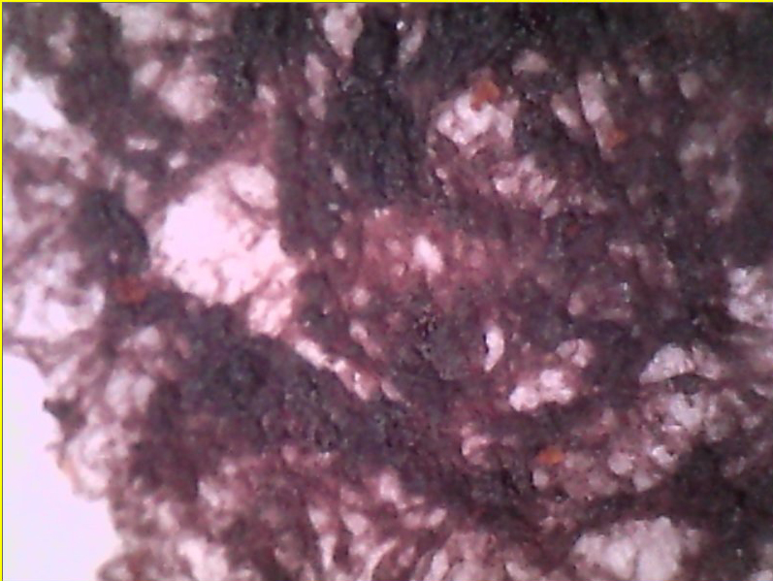
A desiccated structure expectorated from the throat. This example is less defined than the example below, but still shows what appears to be some form of organised vascular-like structure.
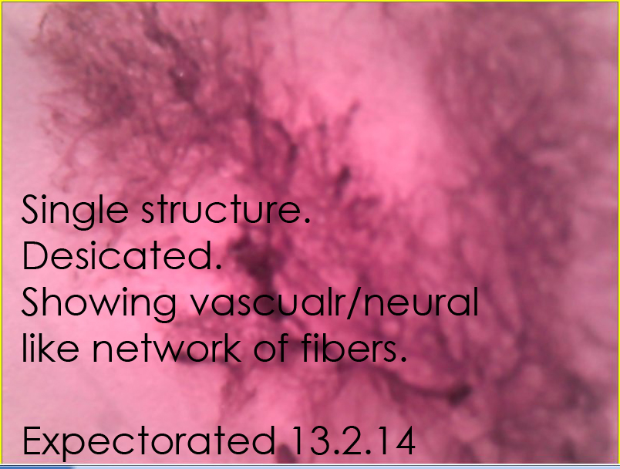
The above image shows the very clear vascular-like structure of these formations. I shall resist calling them organisms as it is not yet clear if these are living in the traditional sense or not. Initial basic tests suggest they are composed mostly of a form of plastic, probably polymer. Despite this, if the source is confirmed as being atmospheric fibres then the fibres are not simply coagulating, but actually assembling in some way into the complex structures we see in these and other images. This would suggest some form of autonomy, which may constitute being referred to as living, active or something similar. The term biosynthetic is often used to describe this type of substance.
This really is not an area I am qualified to talk about suffice to say that one does not need to be an expert in biosynthetics or nanotechnology to realise something very disturbing is being witnessed here. There seems no logical explanation for the nature of, and presence of, these structures in the throats of healthy human beings.

Induced Cumulus
We have seen examples above of persistent trails and the variation of formations that can result from possibly different combinations of atmospheric conditions. Now let’s look at the 2nd type of cloud formations that we believe are created as a result of the fibres being sprayed by Boeing aircraft (and possibly others). This is a separate program and probably unconnected in purpose to the persistent trails. These fibres are present in our air every day in huge numbers, and saturate the air we breathe. The size of these fibres is likely between 40-50nm, which seems to be the ideal size for condensation nuclei.
The image below is of a sky that has clouds that have formed in what most people would consider a natural way, but these clouds are not entirely natural, they are ‘induced’. If the air is filled with tiny particles and moisture is present as the day warms up, the moisture binds to these fibres which act as condensation nuclei, and the result is cloud formations. These clouds look, to most people, completely normal but the size, shape, definition, distribution and the overall milky nature of the sky are evidence of the fact that these clouds have not formed naturally, by which I mean not around a natural nuclei.
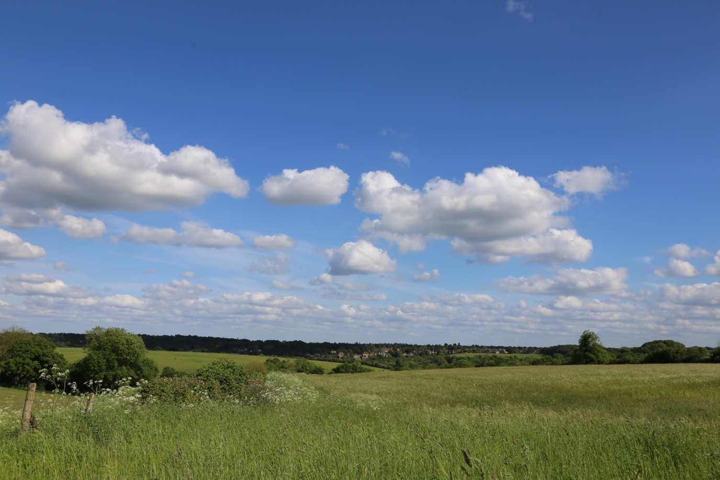
In the image above we also notice the milky horizon. This is now a daily feature of our sky, and due to the presence of these fibres. When we start to look more closely at the situation, we also realise another host of unusual things about how they form. From early morning right through to late afternoon there is a very distinct pattern. Leaving aside the long persistent trails or any natural clouds that may have drifted in from the sea, each day the sky will start off clear at dawn and slowly as the sun rises and the sky fills up with haze, we see the formation of very small fluffy blobs. This is ubiquitous though, and happens simultaneously over huge areas- anywhere the fibres have been sprayed. We notice that these little fluffy clouds grow gradually in size, again all simultaneously. We often also notice that they seem to form in vast lines or rows. We don’t know at this stage if this is significant in terms of whether we are witnessing their formation following the pattern of the aircraft that spray the fibres or if some other factor is involved. More observation is needed; suffice to say this is not normal clouds formation.

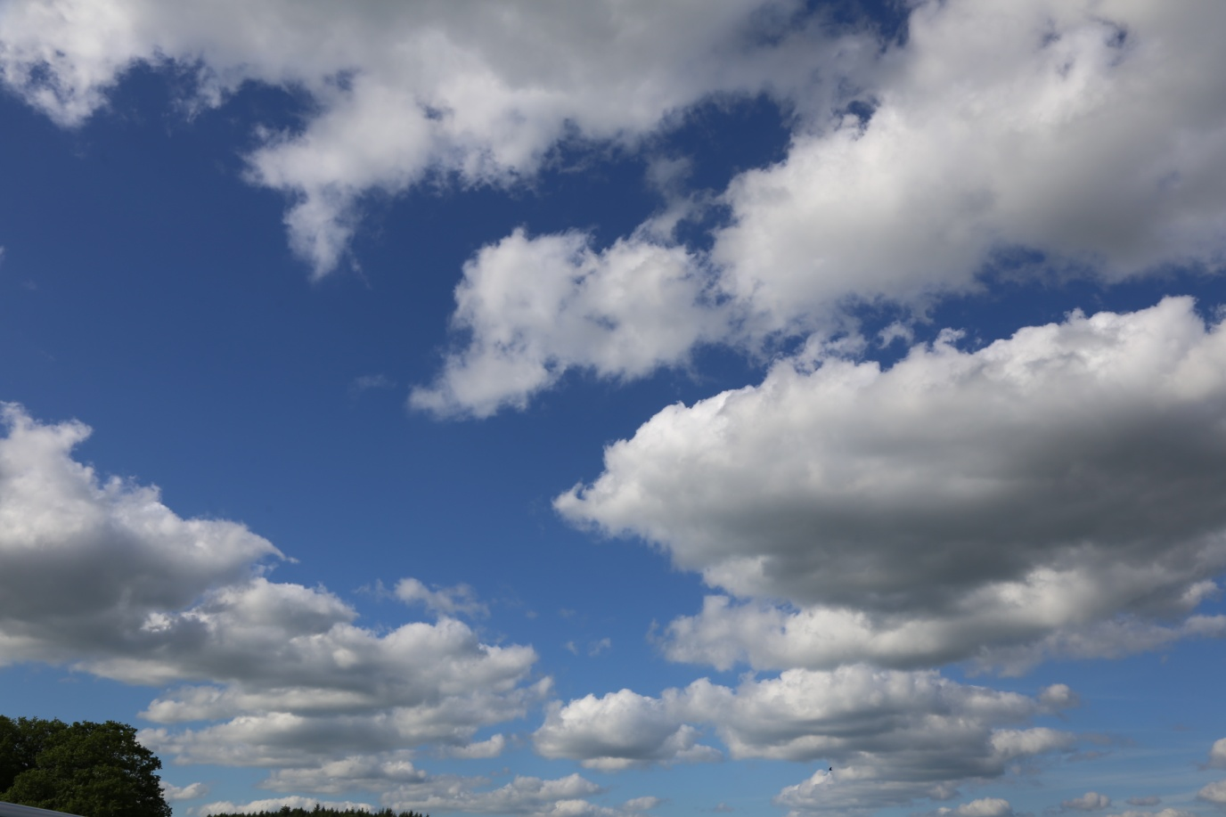
Induced Cumulus form in vast rows of very similar looking formations.

Smogs and smokers
This is the 3rd type of trail left by aircraft that I have identified. These trails have been filmed twice (by me), and in significant numbers over several hours. Several images exist of similar looking trails, but I have not seen other filmed evidence. The first occasion, as seen in the film Smokers was filmed over centrail Europe in February 2014. More recent footage was over Italy, France and the UK, the latter being very important as it allows for legal action in the UK against the CAA for allowing such activity to take place.
Many scientists at the IASS Climate Engineering Conference 2014 reported having seen similar trails left by aircraft and in far flung places such as South America, so it is fair to assume this is not a localised phenomenon. This really is the silver bullet in the entire Climate Engineering expose’ because there is no atmospheric condition, fuel or engine type that can produce smoke like this under any conditions, so if aircraft are involved in spraying smoke, it is perfectly reasonable to accept they are also spraying the other 2 types of trails that are described in this document.
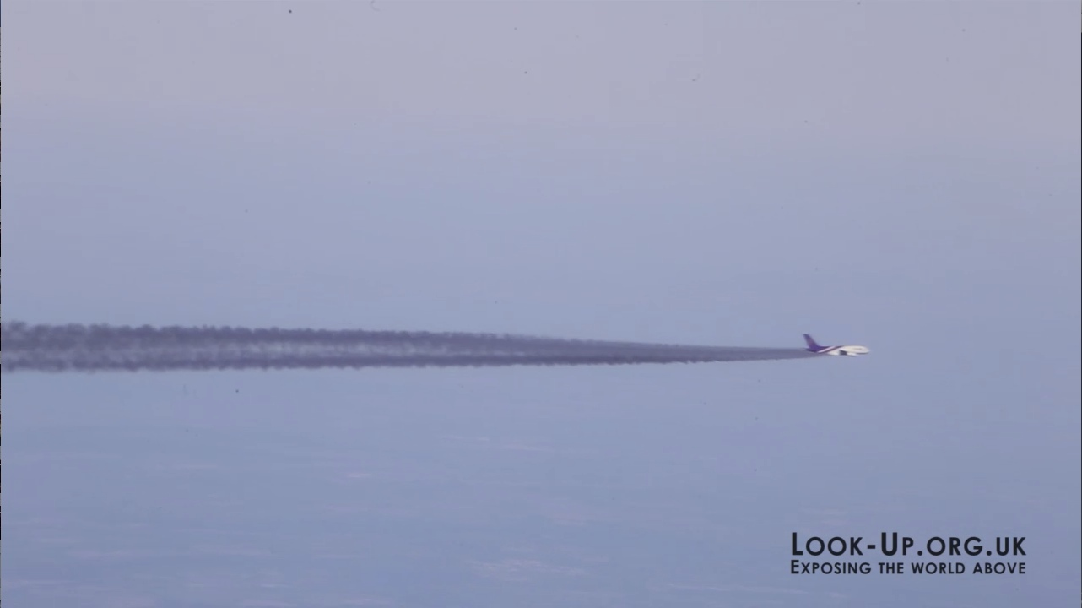
If you watch the video you get a clearer picture of what is happening here
www.vimeo.com/88080046
Some of the aircraft I witnessed in this film are scheduled passenger flights with passengers. Others, such as the ones pictured here were listed flights to the far-east, but were travelling in formation and so are unlikely to be genuine flights carrying passengers. Then there is a fleet of Smokers which travel back and forth in repeated patterns. Those aircraft were not listed on Flightradar24.com, and so had switched off their transponder systems so as not to be trackable. They also flew dangerously close to our planes, passing right underneath us as close as a 200-300ft. Thick black smoke aside, that is not what could be described as safe or normal.
What we see in this film is clearly not normal aircraft behaviour and clearly not normal aircraft exhaust. I consider this to be the most important evidence to date to show that aircraft are being used to spray substances unknown into our atmosphere, in large quantities and over large areas.
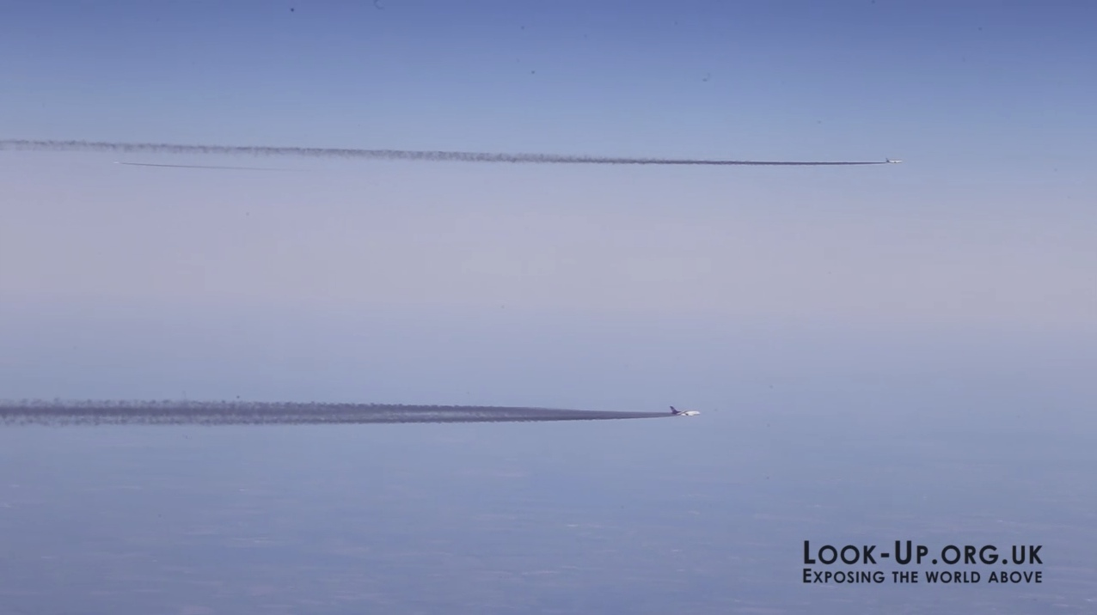
Above we see 3 planes. The two travelling left to right were scheduled flights we believe, from Frankfurt. Thai Air and Condor were the airlines. The 3rd plane, just visible in the background, we cannot identify at this stage as it was not visible on Flightradar24.com, but is likely to be part of the unidentified fleet of Smokers seen travelling over Eastern Europe.

What exactly is going on here then ?
When I first filmed this I was at a loss to explain what or why. Since returning from the Climate Engineering Conference 2014 in Berlin in August 2014 it now seems obvious what is going on.
The UN/IPCC, global warming/climate change, alarmist movement has now had to base its entire climate catastrophe scenario on the fact that CO2 levels are increasing to dangerous levels that will supposedly cause irreversible, runaway warming. It seems they have had to focus on CO2 because there is nothing else left to focus on, as a result of a large percentage of scientists around the globe, many of whom now form part of the NIPCC (nipccreport.org) confirming that no warming has taken place for 18 years, a fact that the IPCC had to reluctantly admit some time ago.
The threshold for this supposed runaway warming was quoted as 400ppm.This figure has now been recorded, and is being used as justification to try and nudge us towards what can only be described as a climate emergency. It seems apparent now that the term climate emergency is what this is all about.
If we accept that CO2 is the only thing the climate alarmist movement have left to be able to introduce emergency measures to combat this perceived threat, then suddenly it becomes obvious that airlines belonging to the 3 airline alliances, are being used to pump smoke into the sky to deliberately force CO2 levels to increase to the threshold that complicit scientists claim is the 'tipping point'; 400ppm. Suddenly everything makes sense.
We expand on this in Section 16 - Summary of this document.
The effect that this particular program is having seems clear when we look at the ubiquitous smogs that have blighted the UK, and indeed the rest of Europe over the past year or possibly longer. It is claimed by the establishment and media that industry and diesel transport are to blame, but that can be easily disproved with statistics and some simple logic. Polluting industry has declined massively in the last 20 years. Regulations governing emissions from industry and transport have become increasingly stringent over the last few decades. I spoke to one of the chief engineers at Rolls Royce Aviation some time ago who confirmed this and stated that their engines are now incredibly efficient due to stringent EU regulations, and there was no way that aviation could be blamed for the smogs. That is, of course, unless the aircraft were pumping something into the air deliberately completely unconnected to normal jet fuel combustion.
The following 2 images are typical of what we see on a daily basis now. This is not mist, or fog, or pollution. We spoke with the MET Office who tried to explain it by suggesting this was pollution that drifted from London to Devon. London is 200 miles away, and on days when the wind was blowing in an easterly direction it still happens. London is also an area of approximately 600sq miles. These smogs were reported from South Devon all the way to Mid Wales, and the Cotswolds, so we are looking at an area of tens of thousands of square miles. How does smog spread out to cover that kind of vast area and stay so dense if it has originated from a single city. Obviously this explanation is completely untenable, especially when we see these conditions repeatedly over many months and during all possible atmospheric conditions.

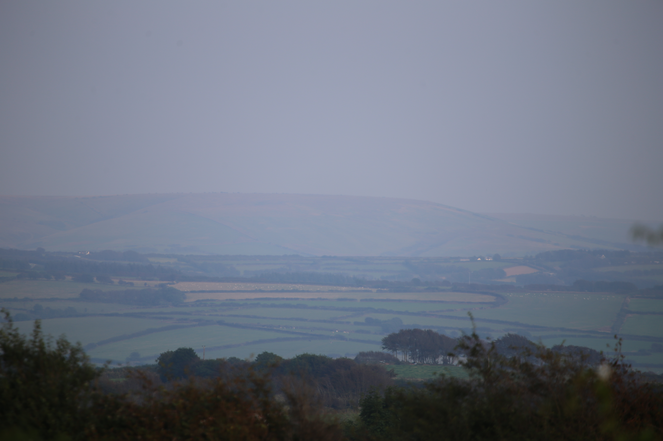
This is a ubiquitous grey/brown smog caused by deliberate ‘pollution’ in order to raise levels of CO2. If we compare the 2 images above we see exactly the same grey/brown smog obscuring the view of the land from the aircraft as we do on a ground based image taken in the UK. This is not industrial pollution. It is statistically impossible for that much smog to be produced in European skies from industry and traffic. This is deliberate pollution from aircraft.
Both images were taken with the same camera and lens and are jpeg images that have not been altered in any way. We have hundreds of other similar examples.

9.2 - Altitude
The MET Office confirmed to me in an email last year that natural contrails can only occur at temperatures of -57 Celsius. They also stated that they can only form above 37,000ft, but they seem to have changed their mind about this figure. In a recent recorded telephone conversation one of their telephone representatives quoted 40,000ft as the current figure. This was very interesting and I asked them simply because we see trails, persistent and haze trails, at altitudes as low as 18,000ft, and the MET’s own radiosonde data shows that we do not experience those kinds of temperatures in a temperate zone until about 35-37,000ft or more (as suggested by the MET employee during the original conversation in April 2014). Seeing any trail at 18,000ft in the UK is completely unnatural under any circumstances so no amount of figure massaging can account for this and explain away the very low trails we see from aircraft passing over London especially on a daily basis during all seasons and with all atmospheric conditions.
Reference the document below:
National Meteorological Library and Archive
Fact sheet No. 13 – Upper air observations and the tephigram

The email sent to me by the MET Office in response to my concerns about persistent trails included the following text:
“There are fundamentally two forms of contrails; those that are non-persistent and those that are persistent:
If humidity and temperature are in the right balance (temperature must be below – 57 °C) these condensed trails cannot evaporate again and so persist for some time and can be dispersed into broader patterns by the wind at high altitudes. These persistent contrails can combine with the contrails from other aircraft to form what can effectively be described as high cloud. This can be very noticeable, especially if it occurs near air traffic route “hubs” where many aircraft converge.”
So let’s look at the statement “There are fundamentally two forms of contrail”. So how do we get water vapour behaving in 2 different ways simultaneously in the same sky? We regularly see aircraft of the same type, one producing long persistent trails, one producing short shimmering trails that dissipate quickly, and others in the same area of sky and at the same low altitudes, producing no trail at all. This really makes no sense, and cannot be explained with claims of about atmospheric variation etc. It simply does not add up. 2 aircraft using identical engines and crossing an entire sky at the same time and at similar altitudes cannot leave different trails across the entire sky, it simply is not possible.
Since we released the information about aircraft not being able to produce any trail until about 37,000ft, we have started to see yet more attempts to hide the evidence of what is happening. Many aircraft, especially transient KLM, Aer Lingus and Lufthansa flights, have started to report false altitudes. Often an aircraft seen spraying will report 37,000ft, but actually be flying as low as 20,000ft. We have caught this behaviour in action in the following film:
Fibre and False Altitudes https://vimeo.com/88670677
The above video shows very clear evidence of this practice. It is something we are still seeing on a regular basis as aircraft try to mask their behaviour.

9.3 OWOW – one with one without
If we also consider images such as this one:
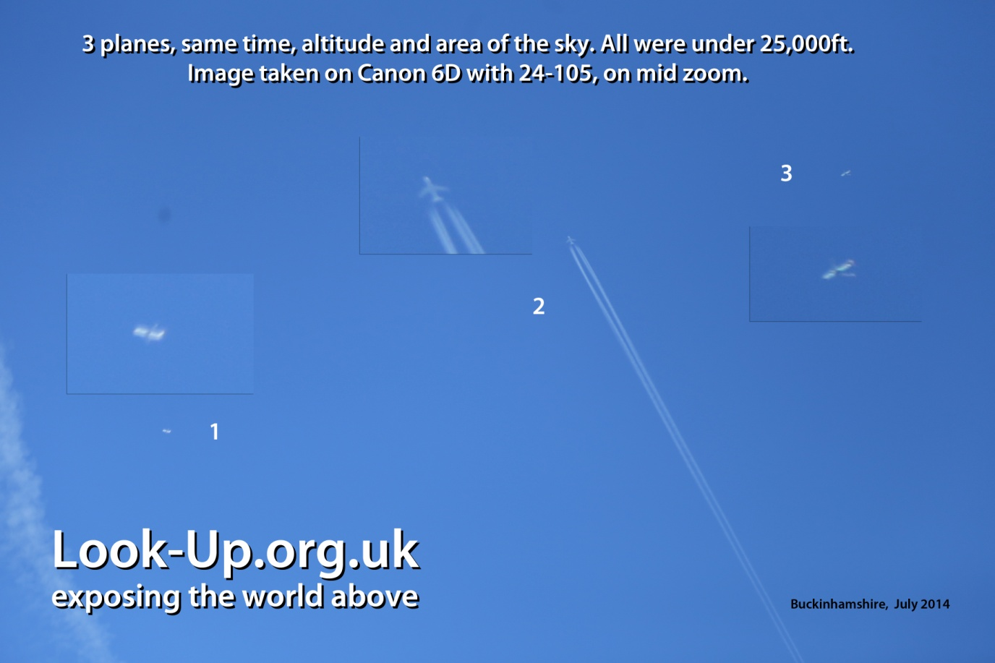
3 planes are seen simultaneously, one with a persistent trail and 2 without

When examining images such as this we realise that there really is no viable explanation, so it is difficult to arrive at any other conclusion other than we are being misled. This is not an uncommon sight, especially for those who watch the sky on a regular basis. This particular image was part of a series that show this behaviour over several minutes, with all 3 aircraft crossing the entire sky, 2 leaving no trail, and one leaving a long persistent trail.
We also have images of 2 planes travelling in parallel across an entire sky, one with a long persistent trail, and one with no trail at all. They were both Airbus A320, and were travelling extremely close together. Even the proximity would raise eyebrows but the trail on one and lack of trail on the other completely undermines attempts to explain this as natural.
This section proves beyond reasonable doubt that when we witness trails at low altitudes, we are witnessing substances that are being sprayed by those aircraft. All modern commercial passenger jets use very similar technology and so such extreme variation such as that witnessed here would not be possible.
9.4 Different types of trails from different aircraft
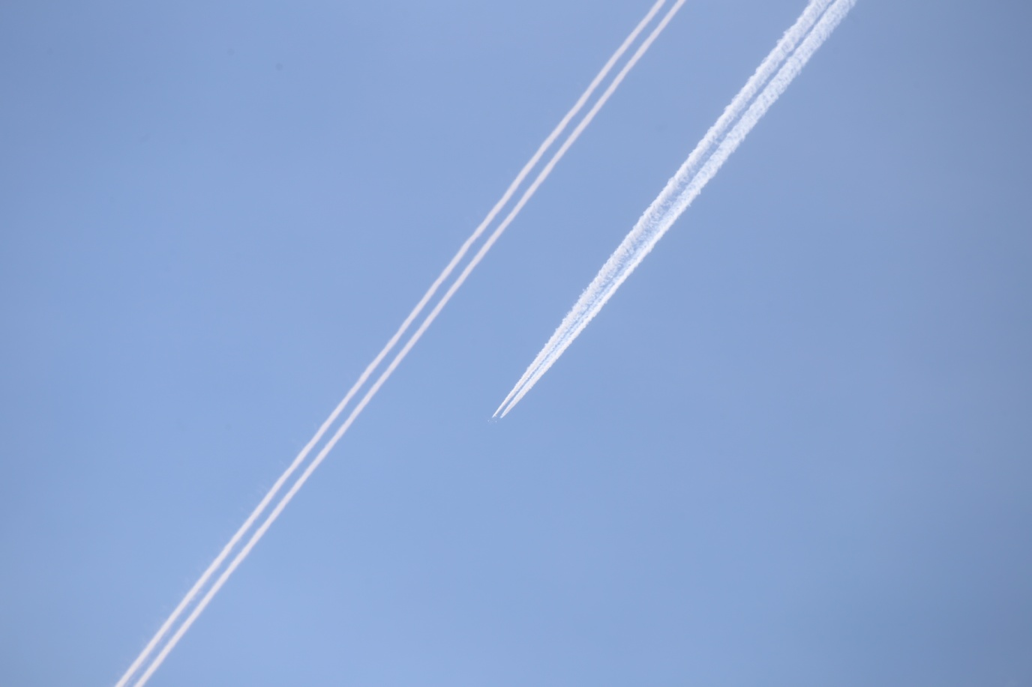
When we boil a kettle, irrespective of what make of kettle, or what kitchen we are in, we always see the same thing. Water vapour does not change in appearance according to what produced it. Granted our atmosphere has tiny variation in terms of pressure, temperature and humidity, but these variations are small and reasonably uniform on a local level. The image above clearly shows 2 planes ‘working in tandem’, a practice we have seen more and more in 2014 and 2015. Each aircraft is producing a completely different type of trail, one of which persists and the other dispersed very quickly. Both were travelling in parallel, once slightly behind the other and at the same altitude and they both crossed the entire sky in this formation leaving trails that looked and behaved very differently
It is not yet understood why this is happening but it does give very suggestive evidence that we are not witnessing water vapour, and are indeed witnessing climate engineering.
If we were to see short trails on some days, and long trails on others then we might just be able to accept that our atmosphere was causing the variations, but as it stands we see such consistent variation in the appearance of the trails from aircraft that we can only conclude that the varying factor is what is being added to the exhaust and not the atmosphere itself.
Obviously this argument is strengthened further by the fact that these two aircraft (previous page) are also well below 30,000ft, and so should not be leaving any trails at all.

The above image is another example of how the various substances from the assortment of trails react differently. Here we see 4 distinct trails (+ a hazer lower right), all of which look quite different. There is no way science can explain this as being simply moisture. This is a small section of sky on what would otherwise have been a clear day and each of these formations was produced by a passing aircraft, all of which were Airbus A320 family.
9.5 Different trails from the same aircraft
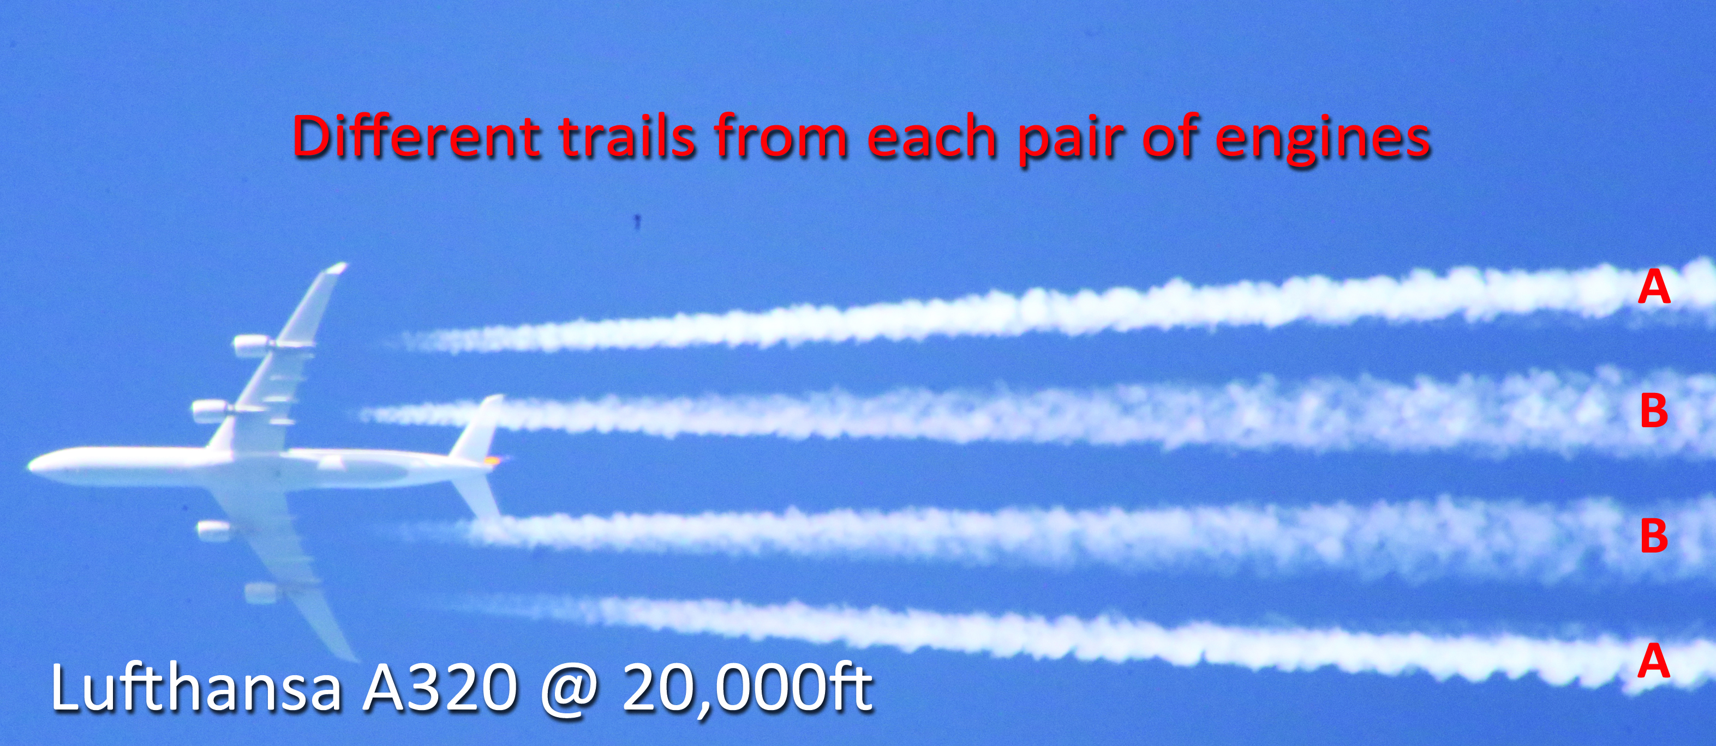
The aircraft in this image is a Lufthansa Airbus, probably A321
This image clearly shows that this aircraft is releasing 2 different types of trails, with the inner 2 sets of pylon pipes producing a less dense pair, and the outer two sets of pylon pipes producing a pair of thinner, denser trails. These trails are clearly not the same and so it can be assumed of different composition.
There is no plane on earth that could fly with different engines, and there is no property of the atmosphere that could be different in such a defined, detailed and consistent way, so once again we see evidence of something unnatural.
My personal opinion is that this represents the ‘combination therapy’ similar to what we see in Section 9.4, where a pair of aircraft work together in tandem. It should be noted that whenever we see 4 engine jets we seem to see differeing trails from each pair, inner and outer, but when we see 2 engined aircraft, we used to see 2 different trails from each side, but changed in 2014 and we now see aircraft working in pairs, one leaving a shorter trail and one a longer trail. This technique would make the process less obvious by dispersing them slightly further apart so as to prevent to tell tale signs described. The consistency of this suggests very strongly that the 2 substances being sprayed are designed to interact, or at least be used simultaneously to provide the desired effect. I am not sure at this stage, why they have to do that or what processes are at work, but it is hard to ignore this repeated pattern. Another possible explanation could be it is simply a way of making the trails less obvious than those we see from the 3-pipe delivery systems that produce the very distinctive shapes with the droplets that I described earlier. People are starting to question those trails, so it is not unreasonable to assume that efforts are being made to mask the program, as has been done before in various ways. The behaviour of the entire program seems to change subtly as we release more evidence and so it is not unreasonable to conclude that our efforts are being monitored and that dispersal techniques are being adapted so as to try to mask them, and make them seem more ‘natural’.

9.6 No time for vapour to condense
This is just a hypothesis at this stage and I have not managed to find anyone yet with the qualifications to be able to prove or disprove this, but to me it seems an extremely valid point and one worth trying to prove or disprove.
The cruising speed of the average commercial passenger aircraft is quoted as around 800km/hr. I worked that out to be approximately 5ms per/m. If we look at this image we see (when zoomed in on a high-res image) the trails have formed at 2-3m behind the engine.
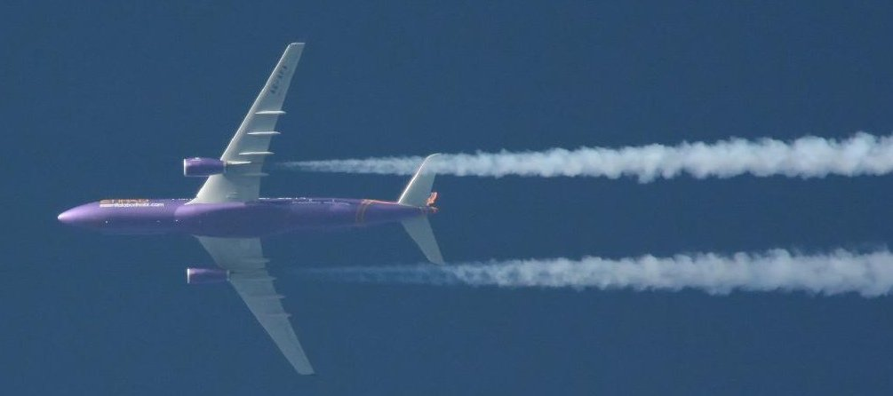
Leaving aside the other fact that it seems to originate from a point source, which would be consistent with the pylon pipes, we simply don’t have enough time for the temperature to drop from 900 Celsius, which is the temperature quoted by the engine manufacturers for the exhaust (that may be at take off, so cruising may be slightly lower but all the same). How does water vapour cool to -57 Celsius, the temperature quoted as being needed to form natural contrails, in just 2-3ms. I do not believe that to be possible and despite having discussed this hypothesis online in several forums nobody has managed to come up with any reliable data to suggest I am wrong.
Until that happens I will consider this as yet another valid point of conjecture in the overall picture.

9.7 – New types of clouds
One of the first things most people notice when they first become aware of the fact that our weather is being deliberately interfered with is all the strange new types of cloud formations in the sky. When we notice all these strange formations we instinctively call the MET Office and ask for explanations.
So many people in fact have been calling them and asking about these strange new clouds, that they have had to lie about the numbers of calls, stated to be in the 10s of thousands by one exasperated operator there (conversation recorded). We submitted an FoI asking the MET Office how many calls they received and the reply was about 30 calls a week. They have 20 staff manning the phones apparently which would suggest most of them are rather bored for most of the week, unless of course the FoI response was not telling the truth.
So much attention has been drawn to these strange new formations that the MET Office also felt the need to invent new cloud types to reassure people that the current climate engineering programs are nothing more than rare and unusual formations that have always been there.

Lets have a look at all the new cloud types that they have invented in the past few years.

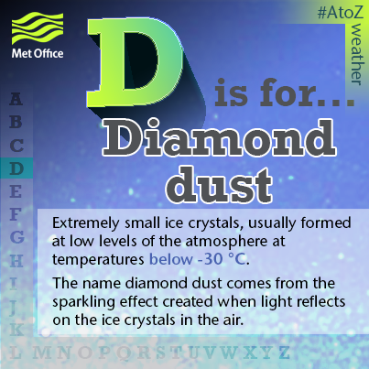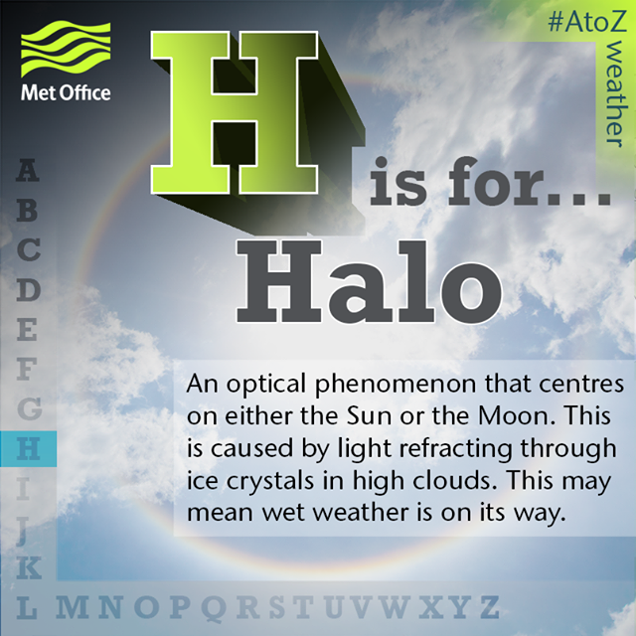
Diamond Dust and Halo.
Diamond dust does not sound like a genuine name, and it does not seem to have any basis in real records of clouds or the atmosphere from what I have seen. It is important to note that merely finding a website that refers to it does not constitute evidence. As we all know, anyone can publish something on a website with a bit of time and imagination. I have sought to verify these things with old printed press. The lack of evidence does not however disprove them, merely that I cannot prove them to be false. My instinct tells me though that diamond dust is just a made up name to explain away some stange phenomenon of climate engineering.
The MET seem to be using the term ice crystals a lot these days. Ice crystals seem to be hanging round in all sorts of places in our skies that they never used to inhabit, and have become the go-to excuse for pretty much everything.
Where is all this ice coming from and why is it now able to exist in the lower atmosphere, despite the fact that vapour from untainted exhaust from jets needs -57 Celsius to freeze and last even for a few seconds.
Halo. Obviously the word halo has existed for a long time, but halos around the sun and the moon certainly have not. Anyone of my generation will know this, and vouch for the fact that none of these strange phenomena used to exist.
The MET Office recently ran a campaign on their Facebook page publicing all these fantastical new things. It could be argued therefore that they have actually become involved in the process of disinformation, which is a very worrying development to say the least. During a recent demonstration I attempted to communicate with the MET Office to ask thenm to explain all these new types of clouds and how they had come about, ut they refused to answer my emails and flatly refused to speak with me on the day. I think that speaks volumes about what is happeing at the MET Office generally.
A
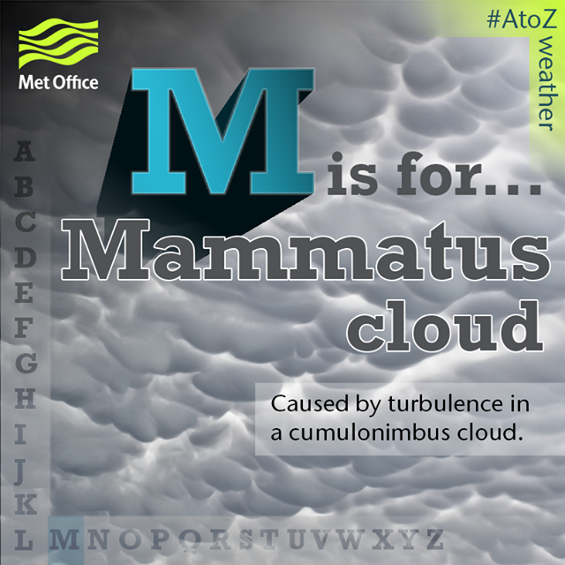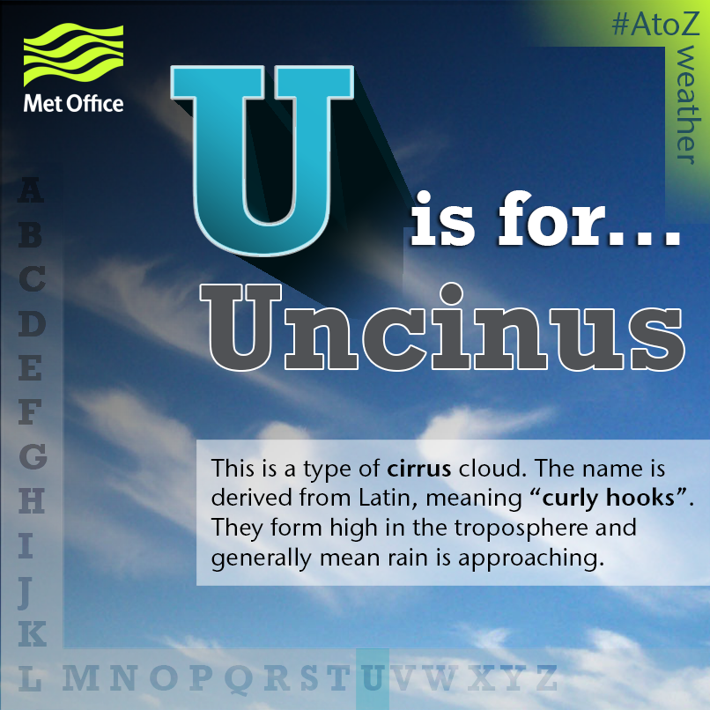
Mamatus and Uncinus are both provable forms of aircraft-produced cloud formations. Both can be seen being sprayed from planes and slowly forming, literally from nozzle to entire sky full. This is not a debateable point. I have evidence of this and indeed it can be witnessed by anybody who cares to take the time to observe.
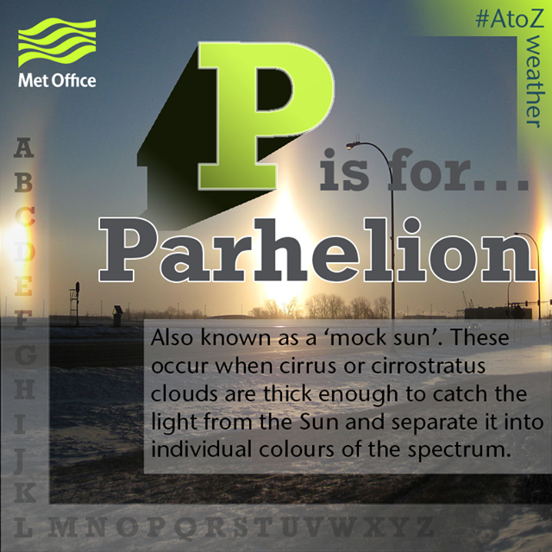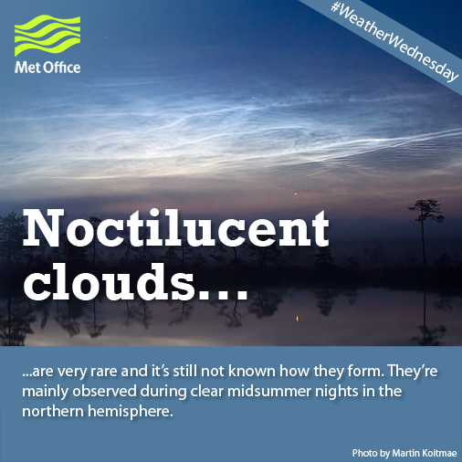
Parhelion and Noctilucent clouds are a bit trickier to prove. I have never seen either, and so it is impossible to say definitely. I would say though that I have been unable to find them in genuinely old books about clouds and encyclopaedias. Both describe phenomena that seem consistent with conditions we know to be the result of heavy spraying of one or more of the substances from current atmospheric aerosol spraying programs.

Section 10 - High bypass turbofan engines
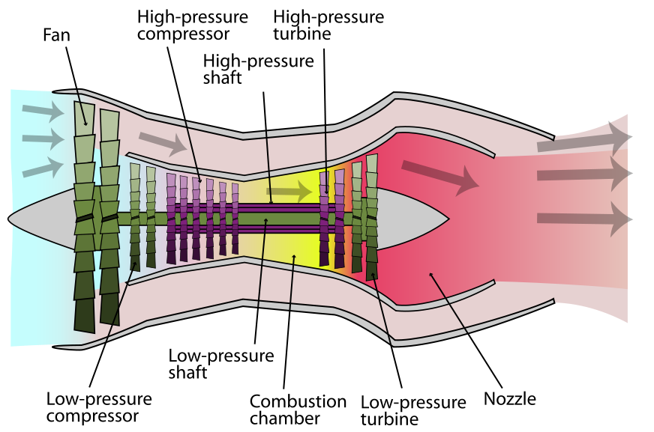
High-bypass turbofan engines produce significantly less moisture, and so should be even less likely to produce trails, and certainly not the huge persistent spreading trails that we see in our skies nearly every day now.
This seems to be yet another ‘inconsistency’. These engines are used quite widely as they are more efficient, and quieter, so many of the aircraft we see leaving trails, should not actually be leaving anything at all. I awaiting some more precise figures on the compositing of the exhaust from these engines, so as to be able to make this point more solid. I will try and expand on this in version 3 of this document.
On the subject of Easyjet, we spoke to Ian Davies the head of engineering there, and had a very interesting email from him.
“These are standard production fit on all Airbus A320 aircraft which is the first thing to clarify and there purpose is to vent and drain engine Pylon compartments in the event of any leakage of pipes hoses and valves contained within these areas. The leaks could be hot air from the engine bleed air system, fuel, as fuel feed pipes run through the compartments and lastly hydraulic fluid if any of the hydraulic system components have failed. It is important prevent the compartment flooding which could be a fire hazard in such a hot area. Al commercial aircraft are required by design regulation to have a venting system.”

Section 11 – The global distribution infrastructure

This is perhaps the most the most difficult aspect of the theory as a whole to convince people of, and yet the one I am most sure of for many reasons. It is, despite the international nature, also one of the easiest to prove if that person were to have access to information within the airline industry, such as flight record and passenger records. I will try and keep the story as brief as possible and focus on the facts. I will expand on this section further on the website.
It all started with this image. On first inspection I disounted it as a glitch, but the more I looked at this area of the world the more I discovered.
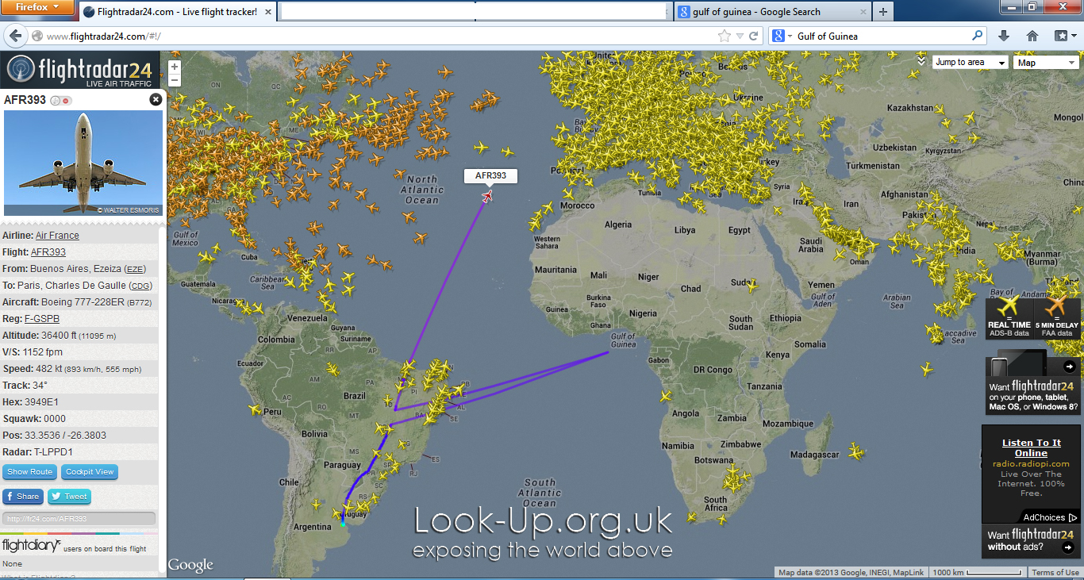
I first published this image in summer 2013. At that time there was an airstrip featured at the coordinate 00N 00E. It seemed obvious though that this was no glitch. Aircraft were seen approaching, stopping, switching off, then reappearing and moving away from the airstrip, and then disappearing again, only to reappear back on their correct route. These flights were stopping off at this location and proceeding to European hub airports and were mostly flights from South Africa and South America. This behaviour continued for some time. A week or so after I published this and another similar images, the airstrip disappeared. It was claimed by a popular debunking website that this was indeed a glitch and that Flightradar24.com had since fixed it.
This was denied by Flightradar24, who stated that their system was entirely reactive, and not able to ad or remove anything, and that they had no knowledge of any glitch at all.
Activity continued in this area despite there being no airstrip. Aircraft would simply approach and then disappear, only to reappear again some time later.
After much head scratching I decided to go to Heathrow and watch these flights landing. What I found was remarkable and cemented this in my mind. Planes that were seen diverting off course were landing at Heathrow with cargo holds full of ULD containers, and no passengers. Some would not even dock at the gate, preferring to simply unload near the same gates every time. Their cargo was them distributed around Terminal 5 to other smaller aircraft and flown of the other hubs such as Dublin, for further distribution.
I firmly believe that an island or military base of some kind exists in the Gulf of Guinea and that aircraft have been picking up the chemicals used in weather modification programs and bring them into European hub airports.
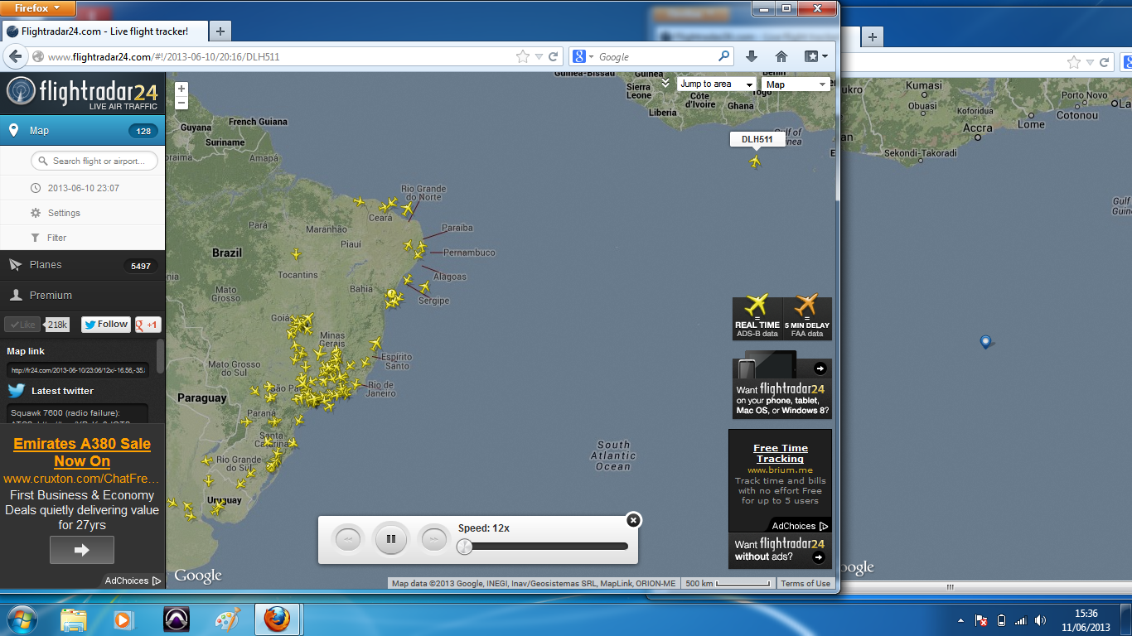
No activity is seen at those coordinates anymore, but I have noticed an increase in flights to airports around the Gulf of Guinea such as Lagos, Luanda and Accra. British Airways, among others, seem to have launched new routes to these places, so I can only guess, not having focussed on this for some time, that the distribution network has simply been adapted.
We also see many flights disappearing from Flightradar24 over North Africa in areas that have good coverage. Obviously attempts are being made to hide the operation. It does not take long to notice serious inconsistencies though.
A recent fact finding mission to Liege Airport resulted in the discovery that a cargo plane had visited the location very recently. Again we see the trace disappear over North Africa, but the destination is clearly marked.
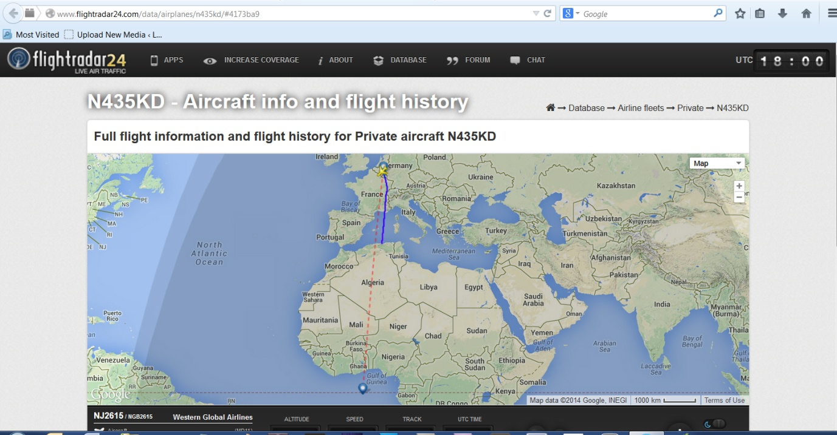

I have suspected Liege of being the centre of at least one aspect of one of the programs and have seen very suspect behaviour emanating from there such as planes flying over the UK slowly, and then simply turning round and returning.
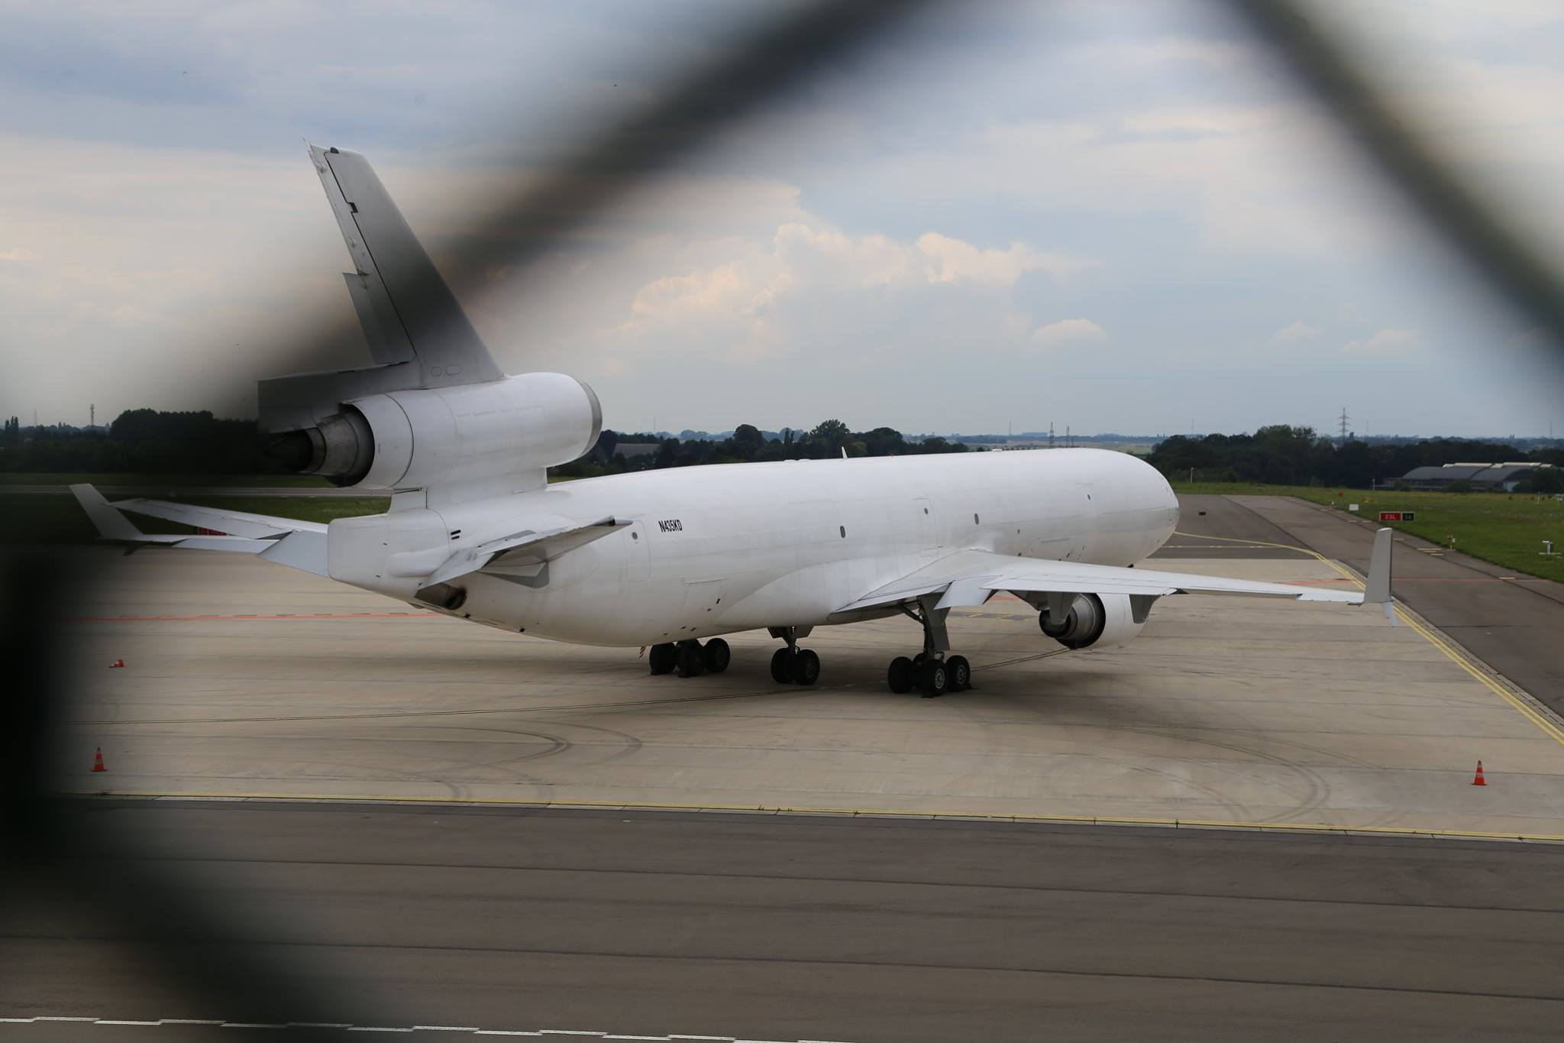
Cargo aircraft at Liege – has been modified in the pylon with dispersal pipes
Further evidence comes from tracking Transavia flights from Amsterdam which state a destination in North Africa, but then actually land at an unmarked airstrip some miles away. As we said it doesn’t take long to find extremely suspicious behaviour happening all over the North and West of Africa.
If one were to attempt to do something extremely big probably illegal, then they would want to have their base somewhere very far away from prying eyes. The Bay of Guinea is about as secluded as you can get, while remaining within easy access for commercial flights to Europe. Nothing shows on Goolge Maps but that is not to say nothing is there. Military sites are often removed by Google, so it would be interesting to obtain old maps of the area to see if there really is an island there, or if this might be some form of floating military base. I can only speculate about the location itself, but there is absolutely no doubt that this is the epicentre of the entire global network.
Section 12 – The containers used to transport the substances

ULD = Unit Load Device. This is an industry standard container for transporting pretty much anything inside an aircraft. When I first suggested this many people jumped up and said that’s just cargo/luggage containers. Perfect.
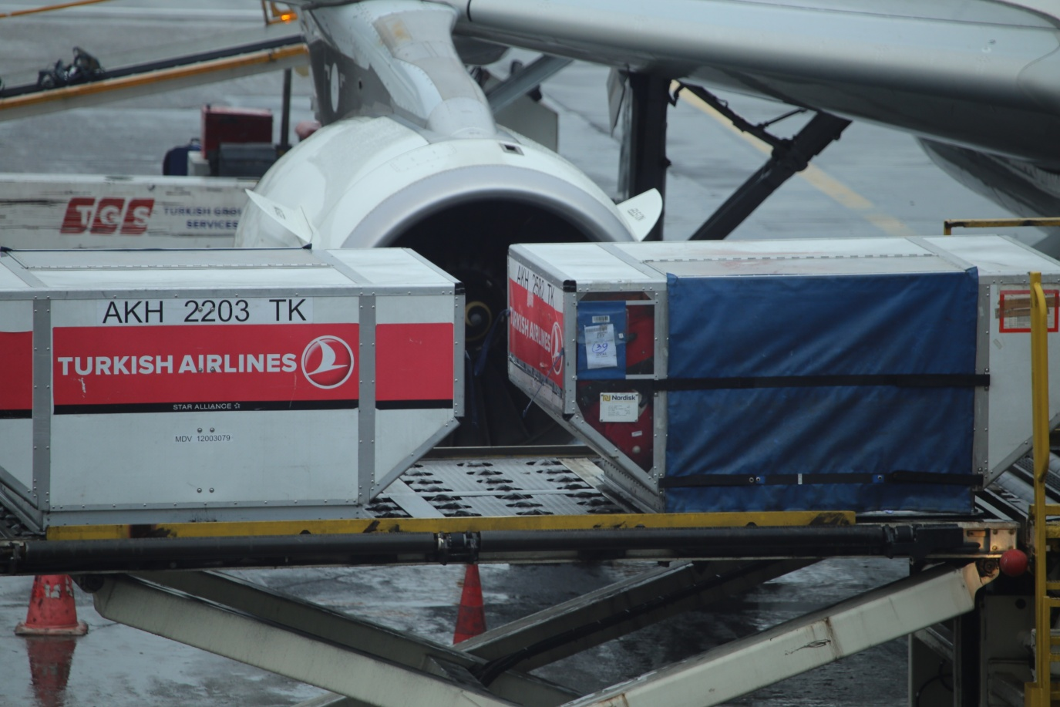
We first noticed these were being loaded off of the flights at Heathrow in large numbers. These were the flights from South Africa and South America that I mentioned previously that had no passengers but were full ULD containers.
I went on a another fact finding mission to Istanbul and discovered that these containers were being loaded onto all of the Turkish Airlines flights right under our noses. They all followed a similar pattern. I had predicted previously that Airbus A320 were now using the front cargo hold for the chemicals, and the rear for luggage, and what we saw confirmed this. I managed to film almost the entire process before being ejected and the gate closed.
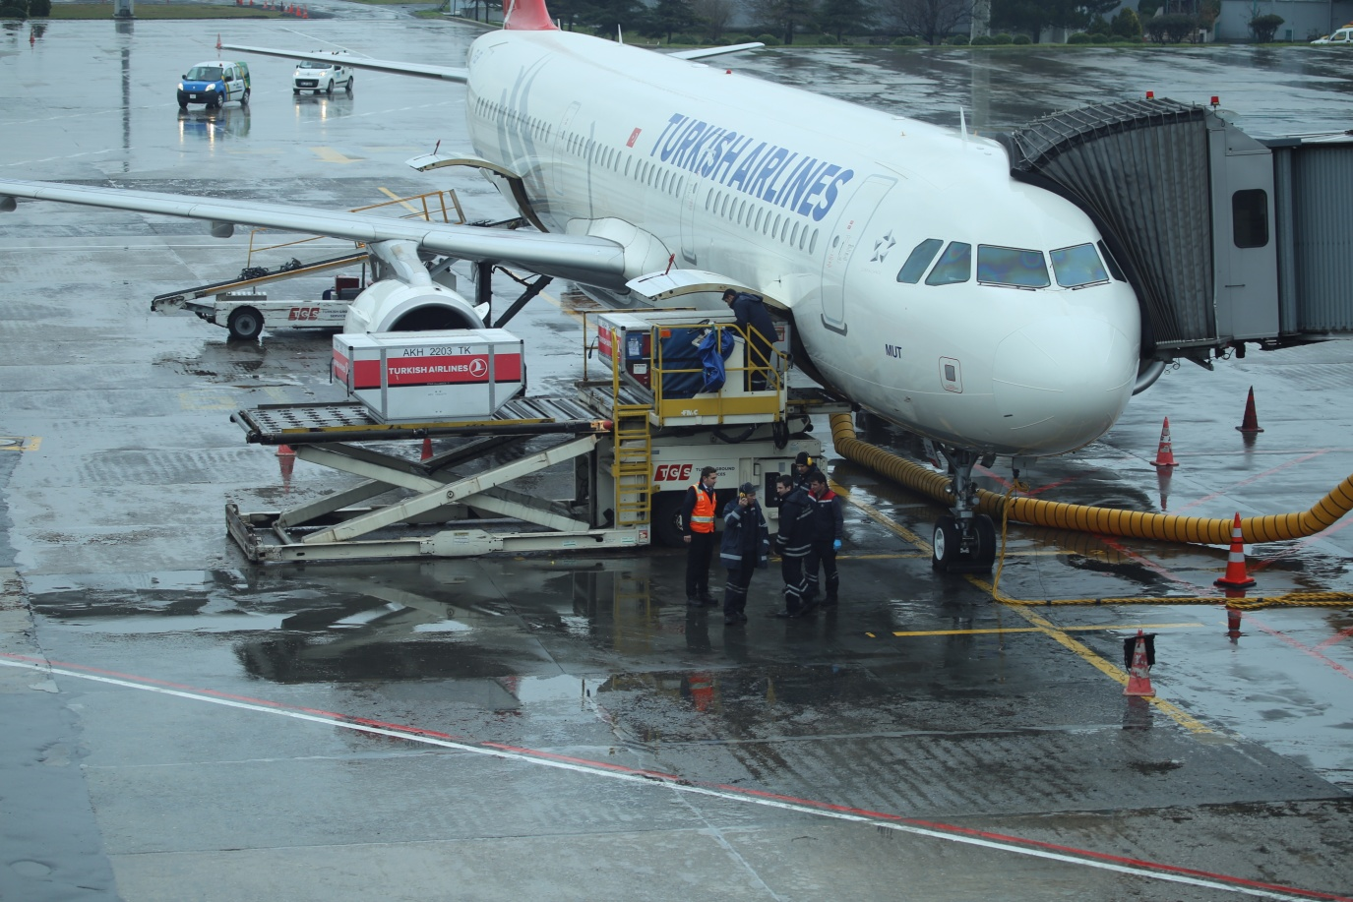
This moment just before the gate was closed and I was asked to leave.
There seemed to be a team of people managing this process quite closely. We can only speculate as to how much they know about what they are doing. We see 3 containers loaded onto the front cargo hold here. Remember there are 3 pipes, and each pipe seems to disperse a different chemical.
Notice also the luggage conveyor belt at the rear of the plane. All the luggage is now loaded on by hand into the rear hold on all Airbus A320 we have witnessed.
I was also told by a member of ground-staff at a UK airport that ground-staff are no longer allowed into the front hold. This will obviously only refer to ground staff at ‘other’ airports. Each airline has its own ‘home’ as it were where its planes are re-filed. This is also an interesting lead and one I hope to follow up on, but one which I hope others will also follow up on.

Section 13 - The dispersal equipment which have been retro-fitted to aircraft

This is the clearest image of the outlet pipes I have to date. They are clearly not original to the aircraft, with welding and riveting being visible, the metal being of different colour, and the overall design having a very home-made look, as though it were a quick modification done as cheaply as possible by someone other than the aircraft manufacturer.
This design is seen (to date) on every Airbus A320 Family aircraft belonging to any of the 3 airline alliances – One World, Star Alliance and Skyteam. They also feature on all Easyjet Airbus aircraft such as the one in this image.
The upper two pipes seem to form constant persistent trails that appear to spread to form a uniform layer of cloud. The 3rd and lower pipe I believe to be a pulse release system.
Insert image of bracelet trail
This is the pipe that produces the puffs of smoke that are the trademark of this system, and of the persistent trails generally. When these trails spread to form cloud we get what is known and cotton wool cloud, basically a multitude of roundish formations of cloud that spread to form the patchy cloud formation we see so often these days. In high humidity this formation becomes what the MET have recently termed Mammatus Cloud.
(see Section 9.7 - New Cloud Types)

A lecture at the recent Climate Engineering called Design of Practical Hardware for Climate Engineering confirmed that this type of technology exists, and is indeed very complex in its design and ability at controlling the flow of the mixture of gas and liquids.
The lecture can be seen at this URL https://www.youtube.com/watch?v=vtSAB81MT-8&feature=youtu.be
Notably 70nm was quoted as the ideal size of particles/droplets to be released. This is of course, proposed technology, and so cannot be considered evidence of current technology, but it gives a good idea of how the current technology is likely to work.

Section 14 – Night flights and The First Wave
Night flights seem to have increased over the last 2 years. I have not had the time t investigate this fully, so this is conjecture, but I know there are strict regulations governing this issue. It seems that aircraft are flying well into the night. Arrivals from abroad and transient flights can often be seen well after midnight.
Cargo flights are, I think , exempt from this, but it would be interesting, following, my recent discovery that all DHL aircraft have also been modified with pylon pipes, to know if the frequency of cargo flights over the UK had also increased significantly over the past few years. As a result the air over the UK is not able to clear as well overnight as it used to.
Then we also look at The First Wave as I termed it.
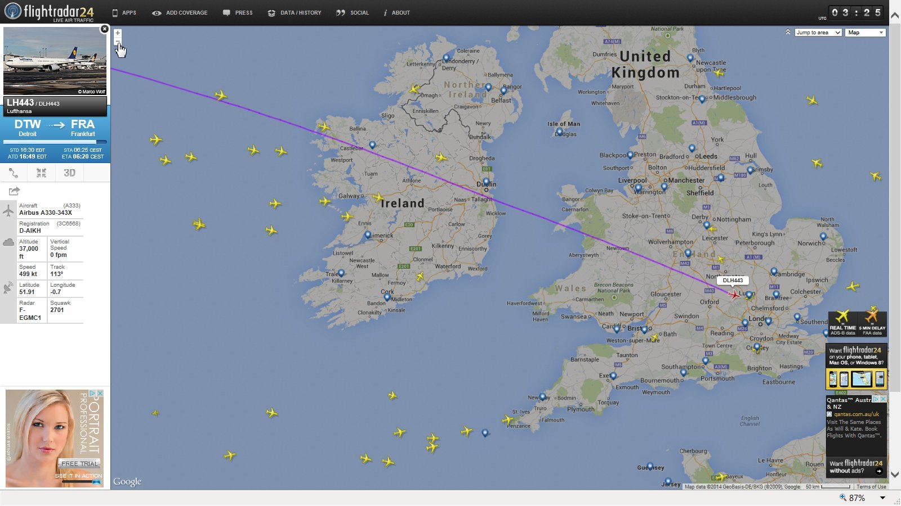
First Wave 05.04.2014
Transatlantic flights from the US now enter UK airspace as early as 3.30am, laying down the first layers of cloud that will serve as the foundation for the our weather for that day. During the summer it can clearly be seen. They are mostly Airbus and they tend to leave the first persistent trails of the day. Generally the first flights will be Lufthansa.
The worrying thing that I discovered though, was that many of these planes did not actually originate from their stated origin. I cross-checked on several occasions in 2013, and the flights were not listed as having departed from the stated origin. Furthermore those flights often simply disappeared from the tracking website as they approached their stated destination. There was also a period, following publication of this information, that flights were seen with a full path on Flightradar24.com, but that path, when examined in detail, did not originate on the ground. There are 2 possible explanations for this. The aircraft passed close to the airport and switched on nearby so as to give the illusion that it has actually come from that airport, but departure details from the airport confirmed this was not the case on the few that I checked. The aircraft took off from the airport stated as its origin, but did not switch o its transponder until it was some distance from the airport. This kind of behaviour has been seen more and more, especially in the UK, following publication of images of Flybe aircraft flying up and down the country in repeated patterns. The likely scenario is that both of these tactics are being used to mask the true behaviour of countless flights around the world that are involved in this operation. where flights I termed these flights ghost flights. When I clicked on the flight paths, they were incomplete and seemed to all begin in the Atlantic about 200 miles off the coast of Ireland. This cannot be explained as ADS-B anomaly, because all the remaining flights that actually landed did have complete flight routes to their origins.
There is insufficient evidence to suggest that only the flights with incomplete paths were leaving trails, and I am not suggesting that is the case, but again, detailed observation would reveal some very interesting things I’m sure.
Since first releasing images of The First Wave, we have seen less and less evidence of this. Most flights do actually land now and seem to have complete flight paths, but we are also seeing fewer planes now. I wonder if we stood at the gates if we would see flights arriving with no passengers, as has been the case at Heathrow Terminal 5.
Much more investigation needs to be done on this, but I think sufficient evidence exists to show that, once again, something is going on here.

Section 15 – Aerotoxic syndrome

This is the only strong evidence to date that what is being sprayed in our skies could be affecting our health. Aerotoxic Syndrome is the name given to a host of symptoms that many long haul and regular flyers experience during, or immediately after, flights.
The website Aerotoxic.org is a place that claims to offer support an information for those affected by Aerotoxic Syndrome, but we have looked at the information in detail, and also at the explanations given by them for the causes of the conditions and none of it makes sense to us.
We deal with this issue in more detail on the website, so will simply summarise in this document. Aerotoxic Syndrome is responsible for a host of symptoms such Fatigue - Blurred or tunnel vision - Shaking and tremors - Loss of balance and vertigo – Seizures - Loss of consciousness - Memory impairment – Headache – Tinnitus - Light-headedness, dizziness - Confusion / cognitive problems -Feeling intoxicated – Nausea – Diarrhoea – Vomiting – Coughs - Breathing difficulties (shortness of breath) - Tightness in chest - Respiratory failure requiring oxygen - Increased heart rate and palpitations - Irritation of eyes, nose and upper airways – Salivation.

The official cause of this condition is supposed to be the vapourising of oil that leaks from the engines. This is a rather ludicrous explanation for several reasons. Firstly the engines in commercial jet aircraft do not leak oil, and especially not on a regular basis. If an oil leak were to occur it would be a major safety issue. Secondly oil, even if inhaled in aerosol form if that were actually possible, cannot produce the myriad of symptoms that are stated as occurring as a result of this condition, as listed above. Thirdly and most obviously, if there were a leak of any kind and of anything it would be fixed immediately. No airline would ignore something of that importance due to obvious dangers to crew and passengers, but also for fear of legal action.
It is utterly inconceivable that this can be the cause of people getting sick on aircraft journeys, and so it is safe to conclude without hesitation that the air passengers are breathing on flights is contaminated with something from outside.
Opinion about what is being sprayed tends to focus mainly on Barium. Other substances are also quoted but here we focus on Barium due to the inescapable similarities of the symptoms caused by Barium toxicity and its effect on the human body, which is mainly Potassium deficiency. The similarities are so striking that it is impossible to imagine that those behind the Aerotoxic.org website have not realised the connection.
The only symptoms we see from Aerotixic Syndrome that are not also seen in Barium toxicity are similar to those experienced by people exposed to the fibres. Fibres are the 2nd type of substance sprayed from aircraft, so here we see a complete picture of the effects of acute high-level exposure to Barium and Polymer nano-fibres released from aircraft at medium to high altitude. Thos substances are then drawn into the cabin air via the ventilation systems of commercial aircraft and breather in an much higher concentrations that would be experienced by people on the ground.
Once again we are faced with evidence that can be described as circumstantial, but this is about as strong as circumstantial gets, due to the lack of other causes.
So to me the Aerotoxic.org website seems to be a cover story for the effects of climate engineering. Aerotoxic Syndrome (AS) is nothing less than an invention to explain the illnesses caused by acute exposure to climate engineering toxins.
Airlines simply would not allow passengers to get sick over an extended period, (this condition has been officially recognised for 6 years now) as a result of something that could be fixed relatively easily, because of the risk of legal action, so why does this organisation not recognise that fact. I cannot accept that the people in this organisation have never heard of climate engineering, and have not considered it at any stage. I also cannot accept that they do not also realise the absurdity of the explanations they give for this condition.
Aerotoxic Syndrome is essentially Climate Engineering Toxicity. If this organisation has failed to recognise this after 6 years then they should be treated with nothing less than extreme suspicion.
I wrote to Aerotoxic.org early in 2014 expressing our concerns. Unsurprisingly they failed to respond.

Section 16 – Routing, population density and the links to health

One thing I noticed over time was the tendency of flights to be routed over highly populated areas. This seemed strange, especially considering that aviation fuel is extremely expensive, and back in the 70s or 80s day, airlines would go to extreme lengths such as smoothing rivets to decrease turbulence I an effort to reduce drag and hence save even small amounts of fuel. Now it seems to be the case that virtually all flights over the UK are deliberately routed over major cities and urban areas. This routing becomes even more confusing when we realise that by doing this the journey is actually extended by some considerable distances, which could amount to huge sums of money, and for no apparent reason.
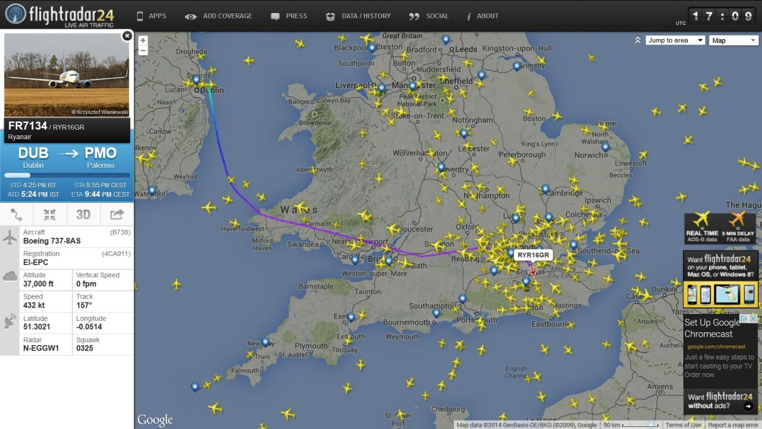
Dublin to Palermo via London
Now I’m no aviation expert and I’m sure in certain cases there may be justification to take a longer route, but why deliberately through a more congested area, hundred of miles out of your way, and noticeably flying over populated areas. Perhaps this is because now the public are keeping one firm eye on the sky, and the other on Flightradar24.com these airlines are no longer able to fly around without passengers and without transponders on?
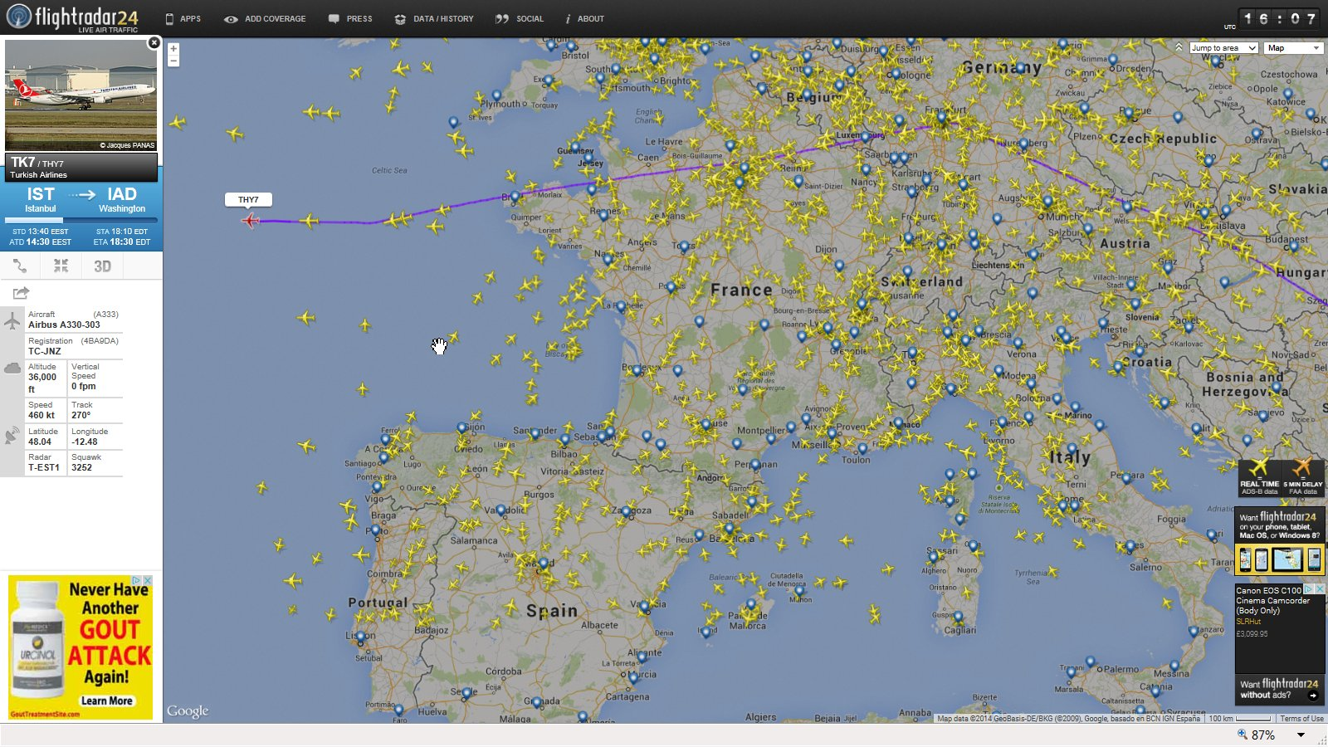
Istanbul to Washington via Paris
More examples will be made available on the website as soon as possible.

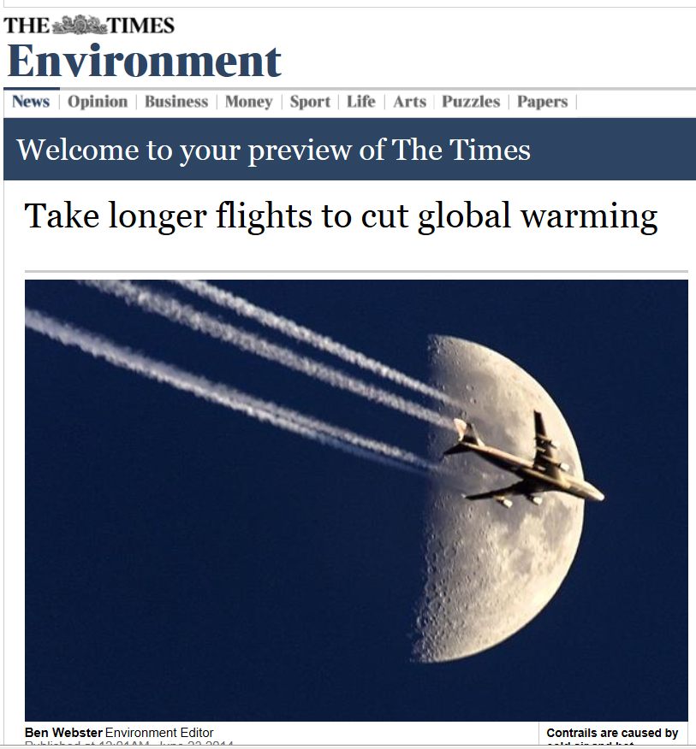
The Times published an interesting article earlier this year claiming that we might have to take longer flights to cut global warming. This was an astounding move I feel. Firstly it admits that planes are now creating trails that turn into cloud cover. Secondly it insinuates that global warming is at least in part, the result of air traffic. Thirdly it directly contradicts what we see happening, which is that flights are currently routed over cities as a default, often causing longer journeys, so the article makes little sense at all.
I think this is yet more evidence of the systematic confusion that is spreading in the aviation industry and the climate alarmist movement in response to the fact that people are starting to realise that we are being lied to.
The link to health
If we then look at the effect these flights are having on air quality in these areas, we see a direct correlation, and not just to air quality but to health also.
Below we see a series of maps showing the distribution of the smog’s in early 2014, and compared with the population density. More worrying though is the link to health problems related to airborne pollutions (map unavailable at this time). Obviously we must consider that built up areas are more prone to traffic pollution simply due to the population density, but the correlation with illness is extremely concerning, especially when we remind ourselves that these aircraft are being routed specifically to pass over populated areas. We can only speculate as to why this is happening, but serious questions need to be asked.
First we look at a time-lapse image of UK airspace. This shows the routes taken by the majority of air traffic to, from and over the UK. Having studied flight paths in great detail I can confirm that this is a very accurate representation, of regular daily activity and not simply a random snapshot.
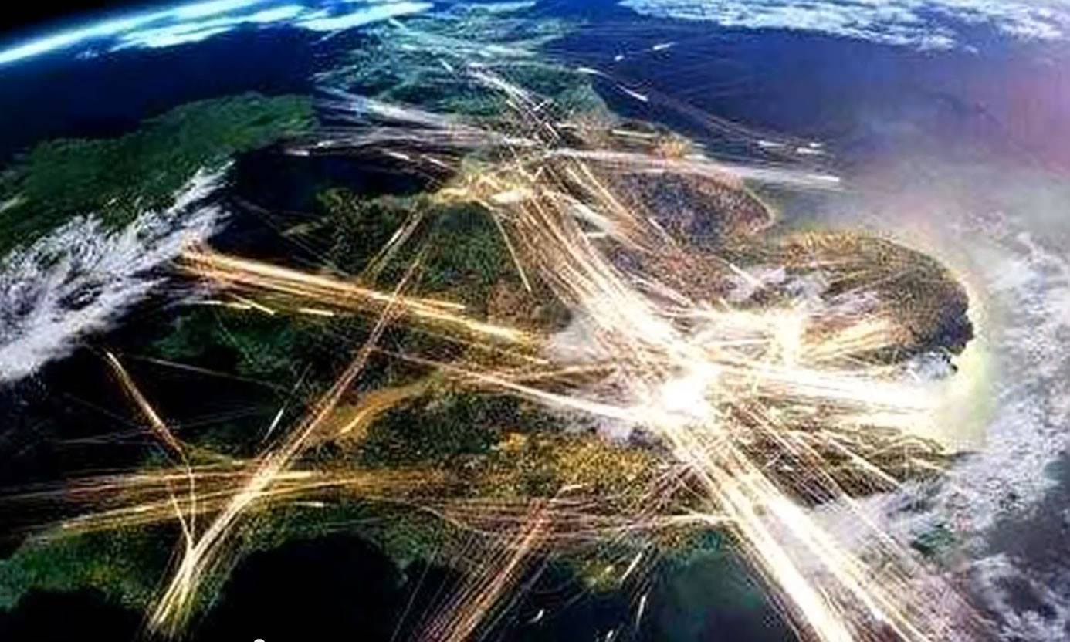
NB these are not trails from aircraft, but traces of the lights on a time-lapse.
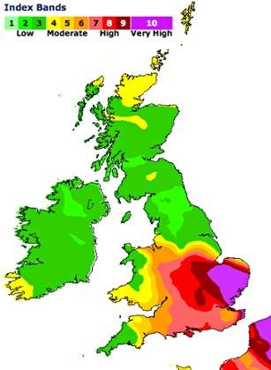

This image showing the distribution of one of the smogs that covered the UK in spring 2014 has a striking resemblance to the map of the flight paths over the UK. There is also a strong correlation between this and premature deaths. Sadly that map is not currently available but will be added in version 2 of this document.
Interestingly we also see some correlation between flight paths and rainfall, which if we are to accept the findings of this document come as no surprise at all, considering the primary purpose of at least one type of trail is rainfall.
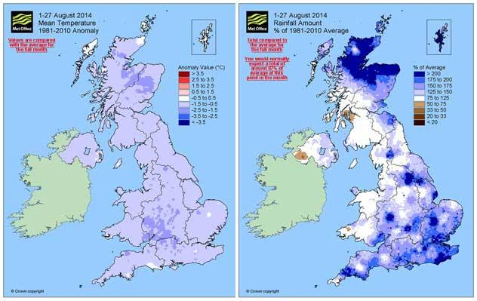

Section 17 – The Military and possible links commercial aviation programs

This section has intentionally been left blank as it still being drafted

Section 18 - The science and the links to political ideology

It seems clear that there is a link, at least in one of the programs discussed in this document, to political ideology, or a political movement.
The persistent trails left by the 3-pipe aerosol delivery systems on Airbus aircraft seem to be primarily being used for the production of cloud-like formations. This could arguable be called constructive if we are to accept that global warming is real, and these are visible, though still possibly illegal, attempts to counter its effect.
The fibres could also be explained as a form of cloud formation program as they promote the formation of cumulus type clouds. They also, however, appear to be collecting in our throats and forming what can only be described as blobs that seem to be attaching themselves to the skin in our mouths and throats. This is really not good. The link, as I stated earlier is still not conclusive, but near as dam it, and when further laboratory results come in then there will be little doubt about the relationship between what we see in our skies and what we find in our throats. As to speculating about their role in our throats, well it could of course be completely incidental. Even if that were the case it is no easy thing to overlook when one has what might turn out to be nano-technology existing, or possibly growing or doing something in the throat.
The third and most obviously divisive type of trail is the smoke. It seems abundantly clear that this is an attempt at pumping the atmosphere full of smoke from the deliberate combustion of fossil fuels in the exhaust plume of the aircraft involved. This obviously helps to achieve the CO2 increase that the climate alarmist movement so desperately need so as to be able to declare a climate emergency, which seems to be the priority among so many of the people behind the climate alarmist movement, as was laid bare at the Climate Engineering Conference 2014. This program also has a potentially very sinister aspect to it though. Particulates are really not good for human health. They have been linked to reparatory and cardiovascular conditions, and in extreme cases can cause death with prolonged exposure to high levels.

To make matters worse, the burning of fossil fuels in the lower atmosphere produces low level ozone. This is different to the ozone layer which protects us, and is situated at over 50,000ft. Low level ozone can cause a myriad of health problems. We discuss this in an article on the website, suffice to say that this presents very serious concerns for us all and questions really need to be asked at the highest levels to establish why this type of activity is being carried out and who is behind it.

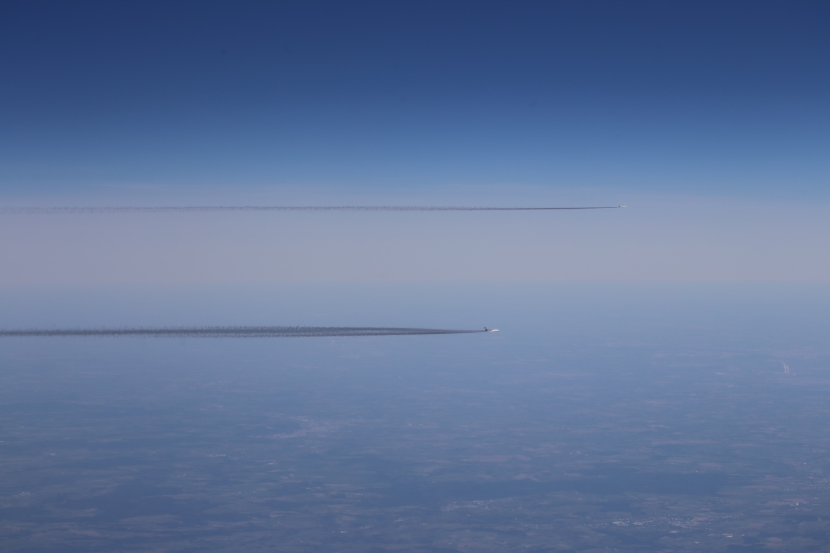
Section 20 – National and international subterfuge
Uncomfortable information is never welcome.
When we analyse the situation as in its entirety and take into account that the visible signs of this program are now so blatant, and so easily provable as being unnatural or manufactured, then we are left with little choice but to arrive at a very uncomfortable conclusion. We, the British public, are being lied to. If politician and aviation organisations such as the MET Office had referred to this ‘pollution’, MPs had taken an interest, and the matter was under consideration we could almost believe that what we were witnessing was an unfortunate consequence of a natural phenomena, or possibly a side effect of some trials of climate engineering but the bitter reality is that a wall of silence exists ranging from scientists in the MET, to certain employees of the CAA, NATS, and assorted other organisation right up to our ministers and prime minister. No mention of any issue of air pollution is ever acknowledged in any way. That in itself is a big clue and insinuates that a cover up of ganrgantuan proportions is underway. In the same way that oen accused of a crime refuses to speak in case he incriminates himself, no one in a position of authority that should have noticed this phenomena is prepared to respond in any way. The only exception to this is pre-formatted denials of any form of active programs given by MPs to their constituents. Clearly these have been written by others and are designed to deflect enquiries on the matter.
What is being sprayed almost becomes irrelevant. When we look at the destruction of our weather on most days, even if it were innocuous and just water vapour would warrant immediate action by government and other weather and aviation related organisations, so their silence and denial is a clear sign that they are fully aware that, at best, something is wrong, or at worst it insinuates full knowledge and subsequent collusion. My fear is that we are faced with the latter, as inconceivable as that may be to some there seems no other logical conclusion to draw when this much evidence is on the table and not even an acknowledgement is forthcoming. They are becoming increasingly desperate in their attempts to not have to confront this situation.

It is extremely difficult to know the inctricaies of the various levels of collusion and by whom in each organisation. Certainly it seems hard to imagine that everybvody who works in all the assorted relevant organisation can have full knowledge of exactly what is happening. I prefer to belive that a hierarchy of understanding exsist, with many layers of bluff, disinformation and intimidation at work at almost all levels. Probably only those at the very top of each organisation understand the full implications of all the 3 primary programs we have discovered. This seems the only logical explanation for maintaining such a vast and complex illusion and deception.
Certainly I have spoken to many junior members of the MET team who clearly have no understanding of the situation at all. Other in the CAA and NATS are clearly very guarded about what they will say and some seem positively nervous to speak to me at all, so once again we see the pattern of fear and denial operating. I have reported many aspects of this program in many conversations over the 2 years and have recorded many conversation with such employees. The things I have reported are very serious, everything from near misses at airport that have not been reported, to fleets of aircraft travelling in repeating patterns over the UK, to aircraft leaving trails as low as 18,000ft over London, all of which should be causes for great concern to anyone who works in the industry, were they genuine. The reaction however, is more often than not one of deflection, excuses, fake facts, blatant lies etc. There seems little choice but to conclude that many, many people in the aviation industry are aware that something very big is going on and are totally unwilling to speak about it. I will expand on this section in version 3 with some very specific examples and quotes if I have the time to prepare them. It is to be noted that virtually all aviation organisation will no longer take calls from the public unless a name is given. If you ask for a name they will not give you one. The fear among those who do know seems to be spreading, and I hope the suspicions of those who do not will also be spreading.
One of the best bits of information to date was the confirmation from the press officer of Airbus UK that their A320 family of aircraft leave the factory with no pylon pipes. This was recorded in a telephone conversation and also confirmed in an email.
“Specification and design of our aircraft comply with certification requirements and safety practices to ensure that any potential draining need, linked or not to failure cases, will be adequately performed. As such, Airbus A320 family aircraft have a fuel drain mast fitted as standard in the lower parts of the nacelle (and none for the pylons). It is an airworthiness requirement that any fuel leak must not pool within the aircraft structure to create a fire risk, must be drained away from the aircraft structure, and must be able to be visibly identified during the preflight safety walkaround checks. The nacelle fuel drain mast only serves to identify the very rare occasion of a failure where a fuel leak has occurred and, in the case of such detected failure, then the aircraft would be repaired before its next flight. The mast has no spraying capability, and is only used to drain aviation fuel, in the very rare case of a fuel leak.”
As soon as I tried to follow this up by email supplying the gentleman concerned with images of the pylon pipes, he simply stated that he had nothing further to add. He then proceeded to try and mislead me and change his story claiming confusion about what the pylon was. In a nutshell someone had realised what had happened and silenced him. This is not the first time this has happened.

Remarkably the collusion extends even to regulatory bodies such as EASA. On applying for information on the approval of the pylon pipe modifications to Airbus A320 by EASA, I was sent an image by ????? (see below) claiming that the pipes were drain pipes

Section 20 - Crime Against Humanity ?
This is a section that I will deal with only very briefly as legal advice needs to be sought to clarify exactly what the situation is here. The body of this document and the conclusions suggest very strongly that 3 programs of deliberate aerial spraying is occurring on a daily basis and over a huge area of Europe including, but not limited to the UK.
It is difficult to prove conclusively that these programs are harmful but the body of evidence would suggest that on balance they likely are, purely as a result of the chemistry involved in the atmosphere, especially with regards the third type, the smoke. It is hard to imagine that breathing in such contaminated air over a period of time would not harm people, especially those of a weak disposition or the elderly. Further the second type, the fibres, also pose a serious health risk. If as suspected they are of a scale of around 70nm then they too pose a serious risk as particulates, and hence could be classed as very harmful to human health.
If it can be established conclusively that these programs are harmful, whether it be intentional of not, this may well constitute a crime against humanity.
Crimes against humanity, as defined by the Rome Statute of the International Criminal Court Explanatory Memorandum, "are particularly odious offences in that they constitute a serious attack on human dignity or grave humiliation or a degradation of human beings." They are not isolated or sporadic events, but are part either of a government policy (although the perpetrators need not identify themselves with this policy) or of a wide practice of atrocities tolerated or condoned by a government or a de facto authority. Murder; massacres; dehumanization; extermination; human experimentation; extrajudicial punishments; military use of children; kidnappings; unjust imprisonment; slavery; cannibalism, torture; rape; political, racial, or religious persecution; and other inhumane acts reach the threshold of crimes against humanity only if they are part of a widespread or systematic practice. Isolated inhumane acts of this nature may instead constitute grave infringements of human rights, or — depending on the circumstances — war crimes, but are not classified as ??????
Furthermore if the intention to enact these programs while knowing them to be harmful to human health, can also be established then they fall under the ENMOD treaty which is defined as:
1976 Convention on the Prohibition of Military or any Hostile Use of Environmental Modification Techniques

Further information on ENMOD can be seen here:

https://www.icrc.org/eng/assets/files/other/1976_enmod.pdf

This is a much more serious situation and one which the organisations involved will find very hard to explain. Ignorance cannot be used by those at the top of these organisation as an excuse for being involved in a deliberate program of weather and atmospheric modification that is clearly potentially harmful to human health.

Section 21 - Conclusions

Our skies do not look like they used to. No natural explanation can be attributed to this fact. It is reasonable to conclude that, as we have shown that planes are spraying substances into the sky, that the spraying programs are the primary cause.
Several new cloud types and atmospheric phenomena have been ‘created’ by the MET Office in the past few years to explain all the strange things we now see in our skies.
The MET Office’s own data confirms that what we often see in our skies cannot be condensation, due to altitude inconsistencies.
If widespread persistent contrail formation was normal, and had always existed, it would be referred to in weather forecasts. It isn’t, and is only just being tentatively reported by media organisations.
Aircraft have been modified with pipes in the pylon. These pipes are consistent with technology known to be able to disperse aerosols into the atmosphere.
Senior engineers and other members of organisations such as airlines, aircraft manufacturers, and manufacturers of aviation engines have been unable to verify the purpose of those pylon pipes. Some have blatantly lied (on record) as to their role and originality to the design of the aircraft. Others have provided contradicting accounts of what they are for, none of which make any sense.
Falsified images have been provided by EASA in relation to the pipes.
Aircraft are displaying very unusual behaviour consistent with predicted aerial spraying programs. They have been seen travelling in repeated patterns over the UK without landing and without having a stated origin or destination.
Long-haul flights have been seen regularly diverting from their specified course on routes from South America and South Africa, via a common location in the Gulf of Guinea. These are the ‘tankers’ that bring the chemicals into European hub airports.
‘Tankers’ have been filmed on several occasions landing at Heathrow Terminal 5, listed as scheduled passenger flights, but with no passengers. These planes are regularly seen discharging large amounts of ULD cargo.
Since images of the Bay of Guinea were released by my website in late 2013, the airstrip there disappeared. Flight radar24.com have confirmed to us that no glitch exists and that they have no facility to remove airstrips, as their system is purely reactive so we can conclude that whoever was operating the airstrip decided they no longer wanted to be watched. For some months afterwards flights were still seen landing in that area.
New flight routes have been introduced by British commercial carriers over the intervening months to Lagos, Accra and Luanda, so as to facilitate the continuation of the supply chain of the chemicals used in these programs.
Flights have also been spotted disappearing over North Africa, and landing at un-named small airfields, and returning to European hub airports. These flights display no journey information.
Airbus A320 Family aircraft no longer seem to use the front cargo hold for luggage. ULD containers are regularly seen being loaded into the front hold of these aircraft.
Commercial flights, as well as unlisted passenger aircraft are seen spraying all manner of trails in our skies that cannot be explained by natural processes.
Government ministers will not respond honestly or accurately to requests for information regarding these programs, which suggests some form of complicity, or fear of responding.
Organisations such as the MET and the CAA are obstructive and possibly even misleading in their responses to enquiries, and consistently refuse to acknowledge their existence or even the possibility of their existence. Again this suggests some form of complicity or fear of responding on their part.

Section 22 - Summary

Something is definitely going on
It should be clear to anyone who reads this document carefully and in its entirety, irrespective of whether they have any qualifications in atmospheric science, aviation engineering or any knowledge of the aviation industry or indeed any other related discipline that something really big is going on. That something might be open to interpretation of one kind or another, but certainly the evidence here points very firmly to the fact that aircraft are now regularly spraying an assortment of substances into our atmosphere, on a daily basis, and over huge areas.
Some of those substances are forming cloud-like formations. Other substances are filling our air with haze or tiny particles that we are breathing in. Others are filling our air with what amounts to smoke from combustion of what is likely fossil fuels.
Harm
It is hard not to be alarmed by this, and despite lack of concrete proof, even harder not to be extremely concerned about the health implications. This document has attempted not to focus on the health side of these programs too heavily due to the lack of conclusive evidence and seeks only to ensure people realise it is happening. My view is that harmful or not, this has to stop.
It is also unknown, if harmful effects are established, if that harm is intentional or simply consequentially. Even if the latter were the case it would be hard for those perpetrating them to argue that they had no idea, due to the obvious nature of the harm caused by those actions.
All 3 have the potential to be harmful in their own way. Certainly the reduction of sunlight alone could constitute harm as it is known to affect both physical and mental health. Also the tiny scale of the particles that form the haze may make them harmful to humans even if that is not their intended purpose. PM10s. Particles if less than 10 Microns are known to affect human health causing respiratory and cardiac problems.
The third type of trail, the smoke, is most likely to be harmful. Breathing in large quantities of what amounts to smoke from fossil fuel combustion is known to be harmful.
It is also unclear, yet, whether the assortment of programs are illegal, either individually or collectively. They will have to be looked at in great detail by lawyers to establish how it can be taken forward in the courts if they continue.
The fact remains however that they are intrinsically wrong and unacceptable. For that reason alone we should expect those in authority to act with extreme urgency to do everything in their powers to implement the immediate cessation of all of these programs, and respond according to the demands laid out in Section 8 of this document.
The argument used in the denial process seen by some organisations questioned about this subject can safely be described as flimsy at best and ridiculous at worst, contradicting each other, having no basis in science and seem more akin to the excuses given by small children when caught out doing something naughty. For our scientific institutions to be so flagrantly dishonest and unscientific is perhaps the most disturbing and hard to swallow aspect of the entire situation for me personally. Having grown up on a diet of science I have always looked on the scientific community with respect and admiration and considered them to be above the self-interested ideologies of politics. Upholders of truth and seekers of fact. How sad that we now cannot seem to trust the very people at the top of the scientific institutions, as they seem to be trying to hide behind this wall of silence and disinformation as we seek to discover the truth about what is unfolding in or skies.
Industry sources have tried to explain the true purpose for the pipes, but failed miserably and contradicted each other. This paints a very poor impression of the industry and suggests a very high level of confusion and fear about what to say about the pylon pipes, which in turn suggests that the industry itself is not to blame here, but in fact under great pressure to cover up their existence from external forces. Airbus initially admitted them, but as soon as I hinted at this fact online, they clammed up and denied it, and even reverted to trying to change their story. Someone had clearly had words with, and silenced them.
It should be a very simple thing to prove the true purpose of the pipes. Let us see the original plans and let us inspect the aircraft.
I hope others will join me and sign the government epetition that calls for a ban on this, in conjunction with this document. If those in the industry have been told that what is going on is a necessary evil to protect us from global warming then you really need to consider your positions. The climate alarmist movement is a politically and financially motivated one, and these programs are clearly nothing to do with defensive climate control, and everything to do with financially motivated weather control, but more importantly could be extremely harmful to all.
Don’t be part of that. It is inhuman and probably illegal. I will fight this with everything I have and expose all who are complicit so as to protect my son’s future and ensure he grows up in a world that is natural and free from interference.

If we cannot get any truth from our Prime Minister then we can force a parliamentary debate on the issue by gaining 100,000 signatures. Please see the following page for my epetition that calls for an end to all forms of Atmospheric Aerosol Spraying to be banned, and legislation to be introduced to prevent this ever happening again.

Section 8 – Demands

I have drafted this document so as to show clear, basic evidence of the existence of these programs, summarise the evidence and speculate on the situation as a whole. On the strength of the content contained herein, and as a UK citizen I feel I have the right to make the following demands.
I hereby demand that The Prime Minister - The Rt Hon. David Cameron MP and The Deputy Prime Minister - The Rt Hon Nick Clegg MP, as political leaders of our country, do the following:
- Officially respond to this document within 28 days.
- Officially and publicly acknowledge this issue.
- Investigate immediately by all means necessary, and with all powers invested in you, and by use of all relevant government agencies and non- governmental organisations, to discover how and why aircraft have been fitted with equipment to disperse substances unknown during flight.
- Bring about, by whatever means necessary, the immediate cessation of all atmospheric release of any substance from any aircraft during flight over UK airspace, whatever the reason, justification or purpose.
- Legislate to ensure that this practice is outlawed henceforth until full, transparent research and public debate is conducted, and that it is not allowed to be re-introduced in any way, even in the form of trials, without the full knowledge and consent of the people of the UK, by measured means such as a national referendum
- Ensure that legislation covers the release of any material in any form from any aircraft for whatever purpose, including any animal, living organism of any kind, mineral or any combination thereof such as biosynthetic structures.
- Ensure that legislation applies to all UK airspace, and to extend that to a suitable distance from British shores so as to prevent any material drifting into our airspace.
- Take steps to implement the above in the European Parliament so as to extend such a ban to all European airspace, or failing that to obtain guarantees from all airlines that operate transient flights over UK airspace agree to abide by such legislations.
- Introduced legislation to force independent regular inspection of aircraft, aviation fuel, and spot checks of cargo and containers carried by all commercial aircraft, and at all UK airports, so as to ensure that the public can be absolutely assured that this situation cannot continue.
- I also demand that any similar military operations be terminated immediately for the above reasons and subject to similar restrictions and checks as detailed in all of the above points, until independent assessment of their purpose, validity and safety can be established. Refer to Section 14 Military operations and the connection to the commercial programs for more information about this point.

Our sunshine and the air that we breathe are fundamental to our lives, and nobody has the right to interfere with or alter them in any way, without our (the people of the UK’s) permission, not even the military.
I also demand clarification as to why so many requests for information, clarification and demands for action in this matter, which have been submitted by thousands of members of the public over the past few years, have been consistently stonewalled or answered with letters of denial or disinformation by MPs, government departments, aviation and weather organisations, and media organisations.

Section 23 – The current epetition

http://epetitions.direct.gov.uk/petitions/65427

Ban all Atmospheric Aerosol Spraying programs. Regulate aircraft emissions, and legislate to allow independent aircraft and aviation fuel inspections
Responsible department: Department for Transport
The CAA are coordinating, or at best turning a blind eye to, a program of atmospheric aerosol injection, conducted by commercial airlines, including but not limited to British Airways, Virgin Atlantic, Ryan Air, Jet 2, Flybe and Easyjet. The aircraft have been modified specifically for this purpose.
The CAA are routing these planes over populated areas creating vast amounts of cloud cover that would not have occurred naturally, which is reducing our sunlight and affecting our health.
I request that the government force the CAA to act in accordance with its Directions, which state that it has a responsibility to keep air pollution to a minimum and protect the health of the public, both of passengers, and of those on the ground.
I further request the government force the CAA to regulate air fuel, monitor aircraft emissions, and allow independent inspection of aircraft and aviation fuel so as to prevent this situation continuing.

